

Kroot Mercenaries

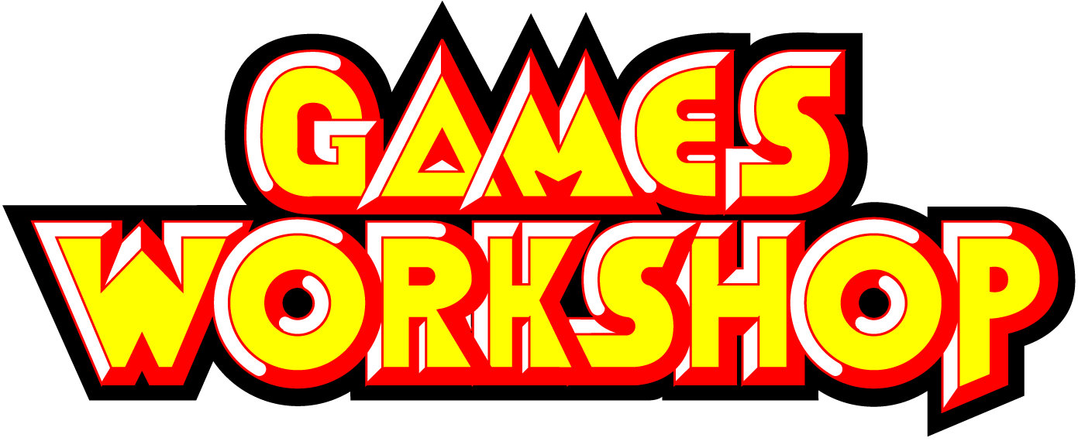
CODEX

Forces of the Kroot

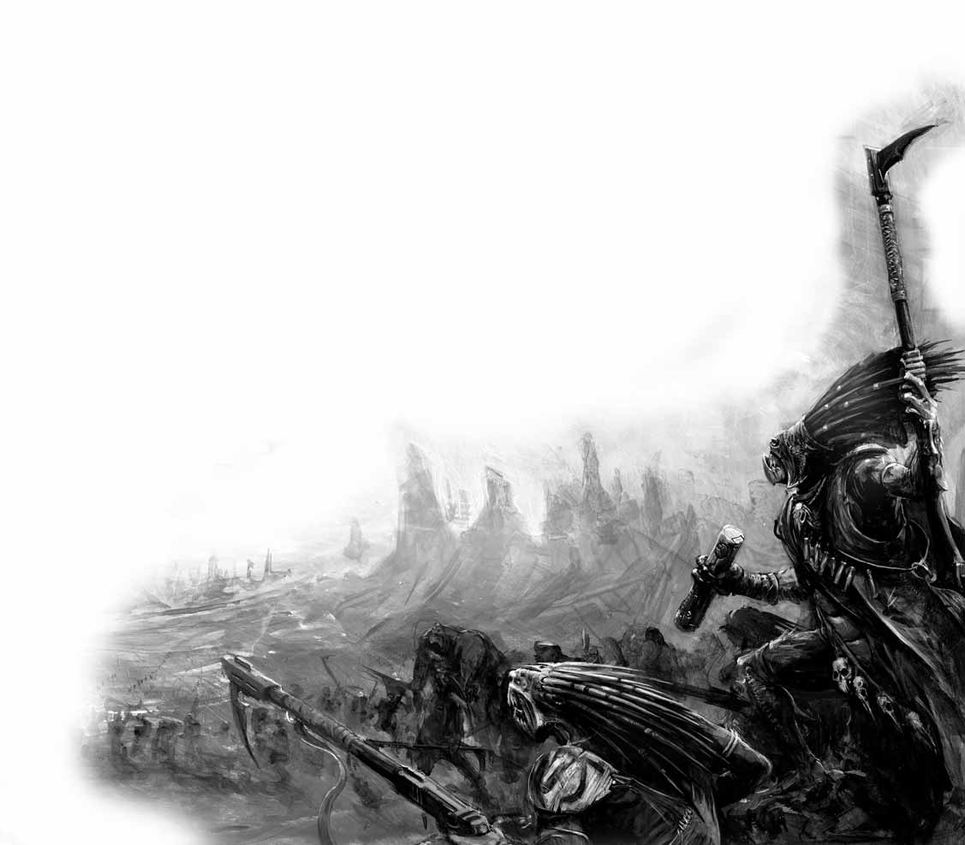
On the following pages are the complete rules for models in a Kroot Mercenary army. The units in the Kroot army list use a number of special rules that are common to more than one Kroot unit. Given here are the details of those rules.

Nocturnal
To represent the excellent senses of the Kroot, many units have the Night Vision special rule.

Fleet
Kroot are extremely agile, and many units have the Fleet special rule.

Eaters of the Dead
Kroot are extremely voracious carnivores and will often feast on the flesh of the fallen. The Kroot have somehow inherited the ability to incorporate useful DNA codes into their own genetic make up. When a Kroot unit with the Eaters of the Dead special rule destroys a non-vehicle unit in close combat, they gain a consumption token. If several units are involved in a combat against multiple enemy units that are destroyed, randomly assign tokens amongst your units in combat. In addition, if a Kroot unit is joined by one or more characters with consumption tokens, all of the tokens for the unit and the characters that have joined are pooled. If an independent character leaves a unit with one or more consumption tokens, you must divide them as equally as possible. The owning player decides who gets any remaining tokens. The following abilities are conferred upon the unit depending on the number of tokens it has:
One token- Feel No Pain
Two tokens- Furious Charge
Three or more tokens- Fearless

Ancestral Worship
The Kroot look to the deeds of their ancestors before battle and take up the aspect of one of the great Kroot warriors of the past. Roll a dice before deployment and apply the result to each unit in the army with the Ancestral Worship rule.
1- All units roll 3D6 when running and choose the highest.
2- All units have +1 WS.
3- All units have +1 S.
4- All units re-roll wounds in close combat.
5- All units have +1 A.
6- All units start the game with a bonus consumption token.

Fast Reflexes
Kroot have a wiriness to them that appears deceptively fragile. In actuality, Kroot musculature is extremely powerful and composed of dense fibre spindles. Swift muscle contractions create a whiplash effect, allowing the Kroot to deliver powerful blows with great rapidity. Warriors that have honed their skills can also avoid clumsy strikes with ease. These Kroot have a 4+ invulnerable save that applies against attacks in close combat only- ranged attacks are taken against the regular armor save. Kroot hounds are even faster and are capable of dodging incoming projectiles, and they are treated as having a normal 4+ invulnerable save that applies against all attacks.

Poisoned Shooting Weapons
Kroot weaponry relies on poisoning the enemy rather than causing physical damage. Poisoned shooting weapons work similarly to poisoned close combat weapons. They do not have a strength value, but they always wound on a fixed number. These weapons cannot damage vehicles, and always count as defensive weapons when mounted on vehicles.

Kroot Wargear
Blood of the Stalker
Some Kroot shapers mark themselves with war paint mixed with the blood of their prey. In many cases, this can allow the Kroot to position themselves advantageously before the enemy is aware of any danger. A model with blood of the stalker counts as having both assault and defensive grenades. This ability is also conferred to any unit they join.

Endoplasmic Pistol
This compact hand-held energy weapon has an elegance that belies its potency.
Range S AP Special
6” 8 1 Pistol, Melta

Endoplasmic Spheres
Using the plasmic energy found deep within Pech's sacred grove, the Kroot have crafted a spherical grenade-type weapon found to disable electronic circuits. When they hit their target, their protective shells burst, releasing the liquid-like plasma and a powerful electric shock. A model with endoplasmic spheres makes one attack in close combat against an enemy vehicle. If you hit, roll on the following table to determine the effect:
- No effect
2-5 Glancing Hit
6 Penetrating Hit

Eviscerator
First discovered by the Kroot when battling the Imperium of man and later replicated by Kroot tech-smiths on Pech, the eviscerator has become a very common sight within Kroot warbands. A huge double-handed chain sword, it was first used by the Kroot for carving up larger prey animals. When used in battle it is a shockingly powerful weapon that, in the hands of a proficient user, can cut through the thickest materials. An eviscerator is a power weapon that always wounds on a 4+.
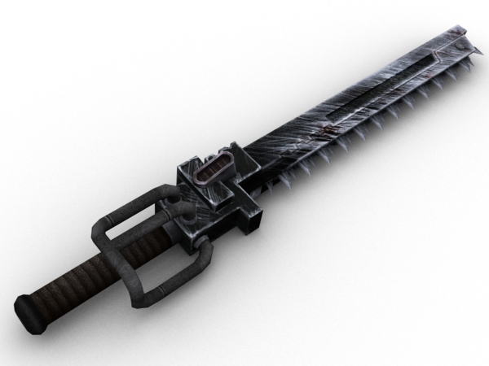

Jangal Seed
This ancient tree seed harnesses some of the strongest magical energies of the greatest shamans of Pech. Once planted, it instantly grows into an enormous tree and roots itself deep into the soil. Within the trunk of this tree exists a portal leading directly back to Pech itself. Once per game, in your Shooting phase, a model with a Jangal Seed may choose to plant it instead of firing. Place a spare small blast marker or similarly sized counter in base contact with the bearer when he activates the portal. He may not activate the portal whilst inside a vehicle. From then on, any of your units arriving from reserve may move onto the board from the portal marker’s edge instead of entering as normal (it does not matter whether these units were intending to deep strike, outflank, or simply move on from their own table edge, and so on). The portal counts as impassable terrain and cannot be destroyed. After activation, the model that had the portal may freely move away, leaving the portal in place. If you have a Jangal Seed in your army, you may keep units in reserve, regardless of the mission being played. Vehicles may not enter play via a Jangal Seed.

Knarloc Mount
Knarlocs are close relatives of the Great Knarloc. They are smaller, more sociable hunters, also native to the planet of Pech. Knarlocs are highly prized by Kroot packmasters as cavalry mounts, enabling them to keep speed with their pack while on the hunt. Models with a Knarloc mount have their armor save increased to 5+ and count as beasts.

Kroot Blade
The weapon of choice for many Kroot warriors, the precise formulation of the various venoms and poisons that are applied to the blade is as old as Kroot civilization itself. The weapon need not be a sword, as the same concoction can be used on the tip of a spear or an axe. A Kroot blade is a poisoned weapon that always wounds on a 2+.

Kroot Bolt Thrower
The Kroot bolt thrower is a primitive but effective weapon, used by the Kroot since long before they encountered the Tau Empire. Like Kroot rifles the bolt thrower contains rounds laden with poisons and toxins adapted by the Kroot for warfare. The bolt thrower is fired by an ingenious hand-crank system that drops bolts from the magazine into position and quickly re-draws the bow string, allowing it to keep up a high rate of fire for little effort on behalf of the firer.
Range S AP Special
36” X 5 Assault 4 or Heavy 6, Poisoned (4+)

Kroot Carbine
A shortened version of the Kroot rifle, carbines sacrifice the blade attachments for suppression fire. Many Kroot packmasters carry carbines instead of rifles, firing off a volley before unleashing the hounds.
Range S AP Special
18” X 5 Assault 2, Posioned (4+)

Kroot Hunting Rifle
This is a variant of the standard Kroot rifle, adapted to fire longer range. However, the additional spiked attachments are lost.
Range S AP Special
24” X 5 Rapid Fire, Poisoned (4+)

Kroot Pistol
A compact version of the Kroot rifle allowing it to be used in one hand, it has a shorter range but loses none of its hitting power.
Range S AP Special
12” X 5 Pistol, Poisoned (4+)

Kroot Rifle
A basic slug-thrower relying on chemical propellants and utilizing ammo rounds containing some of the most deadly toxins on the Kroot homeworld of Pech. The Kroot rifle is fitted with blades near the muzzle and stock. These are a throwback to early traditional Kroot fighting staves. The incredible hand speed that a Kroot possesses due to its unique musculature makes these blades effective assault weapons, accordingly in close combat the Kroot rifle counts as a two handed weapon that grants +1 attack.
Range S AP Special
12” X 5 Assault 1, Poisoned (4+)

Kroot Thrower
The Kroot version of the traditional flamethrower, this gun fires a spray of incredibly potent acid that eats through anything it touches. Roll for the AP value every time it is fired.
Range S AP Special
Template 4 D6 Assault 1

Plasmic Spheres
Although not as powerful as the endoplasmic variety, many Kroot carry plasmic spheres. Upon impact, these spheres burst open and a chemical reaction creates an intense flash of bioluminescence. These count as assault grenades as detailed in the Warhammer 40,000 rulebook.

Power Weapon
A power weapon (typically a sword or axe, but sometimes a glaive, halberd, whip or mace) is sheathed in the lethal haze of a disruptive energy field. Power weapons are capable of chopping through the toughest armor. A power weapon is a close combat weapon that ignores armor saves.

Scavenged Launcher
Kroot serve as mercenaries across the galaxy, and often obtain weapons not available to them when fighting alongside the Tau. Scavenged launchers take many forms and use ammunition composed of corrosive secretions from the various flora found on Pech, capable of weakening even the thickest armors.
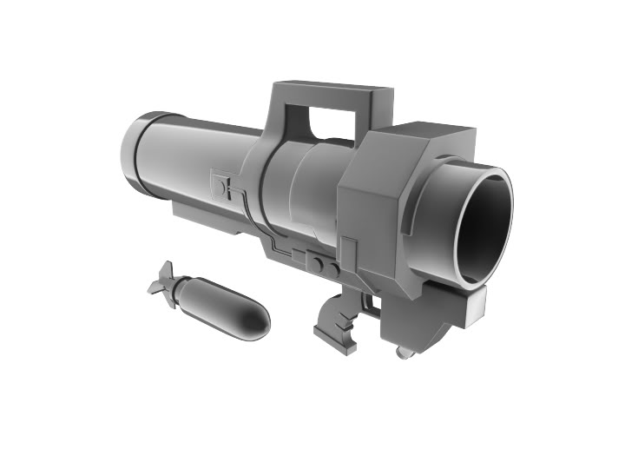
Range S AP Special
18” 8 2 Assault 1, Lance

Stalker Cannon
Stalkers use a different type of ammunition than other Kroot. The Stalker Cannon fires rounds impregnated with virulent genetic toxins, causing its victims to rupture and explode in a shockingly violent fashion.
Range S AP Special
24” 6 5 Assault 3, Pinning

Stalker Pistol
A Stalker loads his pistol with his own personal array of favorite toxins, virulents, and caustics. No two pistols between any Stalkers ever contain the exact same combination of ammunition.
Range S AP Special
12” 4 5 Pistol

HEADQUARTERS

Anghkor Prok, The Great Uniter 240 points
Anghkor Prok was Kroot chief and spiritual leader under whom the Kroot kindreds of Pech united in their struggle against the Orks. After refusing to give way to a larger Kroot at a feast table, he was given the name Anghkor Prok, a term used to describe a bull Krootox sitting intractably on its haunches. It was a name he would live up to throughout his life. Celebrated for his ferocity in battle, Anghkor Prok came to be recognized among his kindred as a visionary leader committed to preserving traditions and values of the Kroot way of life.

WS BS S T W I A LD Save
Anghkor Prok 8 8 3 3 4 8 4 10 4+

Unit Composition: 1 (Unique) Unit Type: Infantry
Wargear: Kroot rifle
Plasmic spheres
Endoplasmic spheres

Oath Blade: Anghkor Prok carries the sacred oath blade used at the moment he swore allegiance to the Tau Empire. It is treated as a power weapon that always wounds on a 3+.

Kaikown Spheres: These spheres utilize the plasmic energy from the slopes of Mount Kaikown, which eventually became Anghkor Prok’s burial site. They are a ranged weapon with the following profile. When rolling to wound, do so against the target’s leadership value rather than toughness. If the target has no leadership value, they are unaffected. Each wound caused heals one wound suffered by Anghkor Prok.
Range S AP Special
12” 10 3 Assault 1, Blast

Mark of the Favored Child: Anghkor Prok has been destined for great things. He is treated as having a 4+ armor save, and a 2+ invulnerable save. But even he can fall out of favor under certain circumstances. Should Anghkor Prok ever fail a 2+ invulnerable save, it is reduced to 6+ for the remainder of the game.

Special Rules: Nocturnal
Fleet
Eaters of the Dead
Independent Character
Fearless

Ancient Warrior: Anghkor Prok has the Preferred Enemy rule against all units.

Kroothawk Totem: Anghkor Prok is extremely well versed in the art of Kroot warfare. He seizes the initiative on a roll of 4+.

HEADQUARTERS

Khibala Yusra, First Born Twin of the Spear 175 points
From the western jungles of Pech, Khibala Yusra was the first born of only two twins that survived their birth into the Murabla kindred. He earned his name when he and his twin were part of a group of young warriors eager to prove their manhood by venturing into the Ygothlac Forest, and were attacked by a rampaging beast. Khibala Yusra’s spear found its mark, tearing through the monster’s heart and lungs, killing it instantly. He went on to become a feared mercenary war chief, honored for his bravery, and swiftly gained command of his own warsphere.

WS BS S T W I A LD Save
Khibala Yusra 9 9 3 3 3 9 4 9 6+

Unit Composition: 1 (Unique) Unit Type: Infantry
Wargear: Plasmic spheres

Spear of the Murabla: Khibala Yusra wields the fabled spear of his kindred. It counts as a two-handed power weapon that grants an additional close combat attack. In addition, every enemy model in base contact with Khibala Yusra loses an attack, down to a minimum of one.

Special Rules: Nocturnal
Fleet
Eaters of the Dead
Independent Character

Fastest Reflexes: Khibala Yusra’s speed is what allowed him to overcome the beast in the Ygothlac forest when other Kroot had failed. He counts as having a 4+ invulnerable save, which is increased to 3+ against attacks in close combat.

Greatest Warrior: Khibala Yusra is the finest warrior of his tribe, and may perhaps be unmatched in skill among any fighters of the great kindreds on Pech. He gets a bonus number of attacks equal to the difference between his weapon skill and the highest weapon skill of any enemy model in base contact with him.

HEADQUARTERS

Master Shaper 65 points
A Master Shaper rules over a mercenary band. He negotiates contracts with employers, leads his warriors in battle and directs their evolutionary development. He will often be armed with the most valuable equipment available, bartered or looted from the many warzones his band has served in.

WS BS S T W I A LD Save
Master Shaper 8 6 3 3 3 8 4 9 6+

Unit Composition: 1 Master Shaper Unit Type: Infantry
Wargear: Kroot rifle
Plasmic spheres
Special Rules: Nocturnal
Fleet
Eaters of the Dead
Ancestral Worship
Fast Reflexes
Independent Character
Options: A Master Shaper may take any of the following:
Kroot blade……………………………………………… 5 points
Power weapon………………………………………… 10 points
Eviscerator………………………………………………. 20 points
Endoplasmic spheres………………………………. . 5 points

HEADQUARTERS

Shaper Council 50 points per model
The Shaper Council sits below the Master Shaper in the chain of command within a mercenary band. Each council member is responsible for a number of kindreds, coordinating their evolution with the other members of the band to obtain the desired mix of skills and abilities.

WS BS S T W I A LD Save
Elder Shaper 4 4 3 4 2 4 2 8 6+

Up to three Elder Shapers may be taken as a single HQ choice.

Unit Composition: 1-3 Elder Shapers Unit Type: Infantry
Wargear: Kroot rifle
Special Rules: Nocturnal
Eaters of the Dead
Independent Character

Guides of Evolution: The Shaper Council directs the acquisition of genetic material for the entire Kroot warband. Each Elder Shaper begins the game with one bonus consumption token.

Options: Each Elder Shaper may take any of the following:
Kroot blade……………………………………………….. 5 points
Power weapon…………………………………………. 10 points
Eviscerator………………………………………………. 20 points
Kroot thrower……………………………….………….. 10 points
Jangal Seed……………………………………………… 35 points

ELITES

Stalker Kindred 18 points per model
Kroot that prefer the art of tracking join the Stalker Kindreds. These Kroot have learned to utilize the gifts of the jungle to adorn their skin with chameleonic salves and to coat their weapons with deadly toxins.

WS BS S T W I A LD Save
Stalker 5 4 3 3 1 6 2 9 -
Stalker Shaper 5 4 3 3 1 6 2 9 -

Unit Composition: 5-10 Stalkers Unit Type: Infantry
Wargear: Close combat weapon
Stalker pistol
Plasmic spheres
Special Rules: Fleet

Guerrilla Reflexes: Though not as agile as Hounds, Stalkers are quicker than most Kroot warriors. They count as having a 5+ invulnerable save.

Guerrilla Tactics: Stalkers have trained for war in the dense undergrowth of Pech. They have the Furious Charge and the Hit and Run special rules and ignore difficult terrain.

Chameleonic Paint: Any enemy unit wishing to target the Stalker Shaper or the unit he is with must roll 2D6x2. This is their spotting distance in inches. If the models are not within spotting range, they may not fire that turn.

Character: One Stalker must be upgraded to a Shaper for 30 points.
Options: Any Stalker may coat his close combat weapon with toxins for 4 points per
model. Close combat attacks this model makes have the Rending special rule.
One Stalker may replace his Stalker pistol for a Stalker cannon for 10 points.
Up to two Stalkers may replace their Stalker pistols with Endoplasmic pistols for 10 points per model.

ELITES

Headhunter Kindred 13 points per model
Headhunters are the finest combat specialists in a Kroot warband. Swift and deadly, they prefer to ambush their opponents and fell them in one quick strike. Young Krootlings strive to be accepted into these groups upon hearing stories of such great warriors like Khibala Yusra.

WS BS S T W I A LD Save
Headhunter 4 4 3 3 1 6 2 9 6+
Headhunter Shaper 4 4 3 3 1 6 3 9 6+

Unit Composition: 3-10 Headhunters Unit Type: Infantry
Wargear: Kroot pistol
Close combat weapon
Plasmic spheres
Special Rules: Nocturnal
Fleet
Eaters of the Dead
Ancestral Worship
Fast Reflexes
Transport: The unit may take a Kroot War Skiff as a dedicated transport.
Character: One Headhunter may be upgraded to a Shaper for 10 points.
The Headhunter Shaper may take Blood of the Stalker for 10 points.
The Headhunter Shaper may replace his close combat weapon with:
Kroot blade………………………………………………… 5 points
Power weapon…………………………………………… 10 points
Eviscerator…………………………………………………. 20 points
Options: The unit may take Endoplasmic spheres for 2 points per model.

ELITES

Krootox Herd 35 points per model
Krootox are ground-dwelling herbivores, far heavier than the normal Kroot. In battle the Kroot latch saddles to their powerful shoulders and climb aboard its haunches. The Krootox herders then lead their charges into battle, and are brutal close combat opponents who most enemy troops will avoid at all costs.

WS BS S T W I A LD Save
Krootox 4 1 5 5 3 4 3 3 6+
Krootox Prime 4 1 5 5 3 4 4 4 6+

Unit Composition: 3-10 Krootox Unit Type: Infantry
Wargear: Jaws and a bad attitude
Special Rules: Nocturnal
Eaters of the Dead

Well Fed: Krootox are fed before each battle to help prevent them from turning on their riders, and start the battle with one consumption token.

Berserk Rampage: At the start of any turn in which the unit is not led by an independent character, roll a D6. On a 1, the Krootox go berserk and inflict 2D6 hits at strength 5, AP- on every unit within 2D6”, friend and foe. The Krootox herd is then removed from the game. On a 2-6, nothing happens, the Krootox are kept in check for the time being.

Character: One Krootox may be upgraded to a Krootox Prime for 10 points.

ELITES

Hunter Kindred 12 points per model
Some Kroot prefer to focus more on the tracking and ranged prowess of hunting, rather than the stalking and ambush method favored in most kindreds. These chosen few hone their skills with ranged weapons, and are called upon to provide necessary fire support on the battlefield.

WS BS S T W I A LD Save
Hunter 4 4 3 3 1 5 2 9 5+
Hunter Shaper 4 4 3 3 1 5 3 9 5+

Unit Composition: 3-10 Hunters Unit Type: Infantry
Wargear: Kroot hunting rifle
Special Rules: Nocturnal
Fleet
Eaters of the Dead
Transport: The unit may take a Kroot War Skiff as a dedicated transport.
Character: One Hunter may be upgraded to a Shaper for 5 points.
The Shaper may take Blood of the Stalker for 10 points.
The Shaper may take any of the following:
Kroot blade………………………………………………… 5 points
Power weapon……………………………………………. 10 points
Eviscerator………………………………………………….. 20 points
Options: Up to 4 Hunters may replace their Kroot hunting rifles with Scavenged
launchers for 15 points per model.
Up to 2 Hunters may replace their Kroot hunting rifles with Kroot bolt
throwers for 10 points per model.
The unit may take Plasmic spheres for 1 point per model, and Endoplasmic spheres for 2 points per model.

TROOPS

Carnivore Kindred 10 points per model
The Carnivore Kindred represents the core of the Kroot Mercenary band. They are flexible in battle and their shapers are always on the lookout for fresh enemy whose special abilities they can inherit.

WS BS S T W I A LD Save
Carnivore 4 4 3 3 1 6 1 8 6+
Carnivore Shaper 4 4 3 3 1 6 2 9 6+

Unit Composition: 5-15 Carnivores Unit Type: Infantry
Wargear: Kroot rifle
Plasmic spheres
Special Rules: Nocturnal
Fleet
Eaters of the Dead
Ancestral Worship
Fast Reflexes
Transport: The unit may take a Kroot War Skiff as a dedicated transport.
Character: One Carnivore may be upgraded to a Shaper for 10 points.
The Shaper may take Blood of the Stalker for 10 points.
The Shaper may take any of the following:
Kroot blade………………………………………………… 5 points
Power weapon…………………………………………… 10 points
Eviscerator…………………………………………………. 20 points
Options: The unit may take Endoplasmic spheres for 2 points per model.

FAST ATTACK

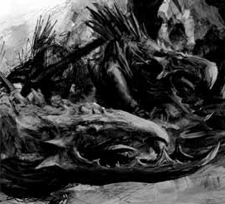
Kroot Beast Pack 12 points per model
Some kindreds have access to a larger proportion of Kroot hounds than others. These are often fielded as fast moving packs, controlled by the ultrasonic whistles of their masters; the wild creatures are then unleashed upon the foe. Other packmasters train flocks of Kroot Hawks to dive on the enemy in a whirlwind of razor sharp talons.

WS BS S T W I A LD Save
Kroot Packmaster 4 4 3 3 1 5 1 8 5+
Kroot Hound 4 0 4 3 1 6 3 5 6+
Kroot Hawk Flock 4 0 3 3 5 5 5 5 6+

Unit Composition: 1-5 Kroot Packmasters Unit Type: Beasts
Wargear (Packmaster): Knarloc mount
Kroot Carbine
Close combat weapon
Special Rules: Nocturnal
Fast Reflexes (Packmasters and Hounds only)
Eaters of the Dead (Packmasters only)
Rending (Kroot Hawk Flocks only)
Options: Each Packmaster may be accompanied by the following:
0-5 Kroot Hounds……………………………………… 12 points per model
0-2 Kroot Hawk Flocks……………………………… 15 points per model
One Packmaster may replace his close combat weapon with:
Kroot blade………………………………………………… 5 points
Power weapon…………………………………………… 10 points
Eviscerator…………………………………………………. 20 points

FAST ATTACK

Baggage Pack 12 points per model
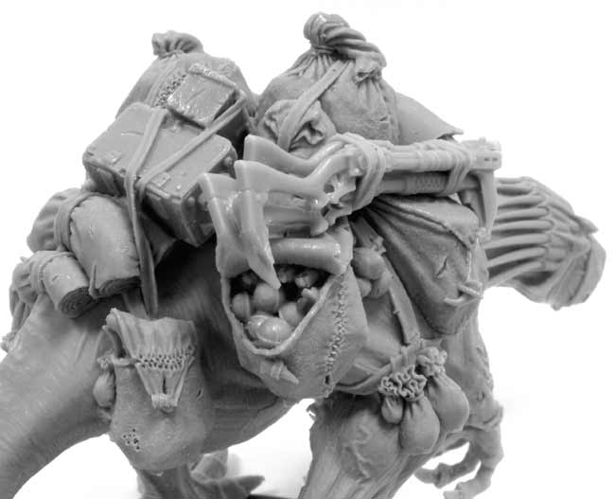
Great Knarlocs are commonly used by Kroot forces as baggage animals, to carry heavy equipment and supplies whilst on campaign. These domesticated creatures are kept chained and muzzled for safety, but are occasionally caught up in a battle in support of the Carnivore Kindreds.

WS BS S T W I A LD Save
Kroot Packmaster 4 4 3 3 1 5 1 8 5+
Baggage Knarloc 4 0 5 5 4 5 4 5 6+

Unit Composition: 1-5 Kroot Packmasters Unit Type: Beasts
Wargear (Packmaster): Knarloc mount
Kroot Carbine
Close combat weapon
Special Rules: Nocturnal
Fast Reflexes (Packmaster only)
Eaters of the Dead (Packmaster only)

Beast of Burden: A Baggage Knarloc is rarely seen in the midst of combat, and will become enraged if harmed. For every wound a Baggage Knarloc takes, it gains an additional attack.

Options: Each Packmaster may be accompanied by the following:
0-1 Baggage Knarloc…………………………………… 40 points per model
One Packmaster may replace his close combat weapon with:
Kroot blade………………………………………………… 5 points
Power weapon…………………………………………… 10 points
Eviscerator…………………………………………………. 20 points

FAST ATTACK

Vulture Kindred 22 points per model
The Kroot species has an avian ancestry, and these kindreds have resurrected this aspect of their evolutionary development by eating the flesh of winged hunters. Although not suited for extended flight, their wings allow them to spiral on the warm updrafts above the jungle canopy and then swoop down upon the heads of their enemies.

WS BS S T W I A LD Save
Vulture 4 4 3 3 1 5 1 8 4+
Vulture Shaper 4 4 3 3 1 5 2 9 4+

Unit Composition: 3-10 Kroot Vultures Unit Type: Jump Infantry
Wargear: Kroot carbine
Plasmic spheres
Special Rules: Nocturnal
Fleet
Eaters of the Dead

Flight Reflexes: Kroot Vultures are incredibly quick as they dart about in the air. They count as having a 6+ invulnerable save.

Character: One Kroot Vulture may be upgraded to a Shaper for 10 points.
The Shaper can replace his Kroot carbine for a Kroot pistol and:
Close combat weapon………………………………. Free
Kroot blade………………………………………………. 5 points
Power weapon………………………………………….. 10 points
Eviscerator……………………………………………….. 20 points
Options: For every five models in the unit, two may replace their Kroot carbines with:
Kroot Bolt Thrower……………………………………. 10 points
Scavenged Launcher………………………………… 15 points

DEDICATED TRANSPORT

Kroot War Skiff 55 points
Ever since abandoning their large hive cities on Pech and allowing them to be reclaimed by the wilderness, Kroot have shunned most forms of technology. The most notable exception to this is the warp-capable warspheres, which allow warbands to travel the galaxy. Similarly, Kroot have recognized the need to travel during a battle, and have adapted Tau skimmer technology to construct war skiffs. When not in combat, groups of Kroot hunters utilize war skiffs to hunt across the isolated prairies on Pech, firing from their mobile weapon platforms at herds of fast-moving game.

BS Front Armor Side Armor Rear Armor
Kroot War Skiff 4 10 10 10

Unit Composition: 1 War Skiff Unit Type: Vehicle (Skimmer, Fast,
Open-topped)
Wargear: Twin-linked Kroot hunting rifle
Kroot bolt thrower
Camouflage netting (5+ invulnerable save)
Special Rules: Nocturnal
Transport: A Kroot War Skiff may transport up to 5 models.
Options: The War Skiff may replace its twin-linked Kroot hunting rifle with a Kroot bolt thrower for 10 points.
The War Skiff may take any of the following vehicle upgrades:
War Trophies………………………....... 5 points
Meat Hooks……………………………… 5 points
Envenomed Spikes…………………… 5 points

War Trophies: The skiff is decorated with the various skulls, pelts, and equipment of those unlucky enough to be hunted by the Kroot. Any Kroot unit within 6” of the War Skiff may re-roll failed leadership tests.

Meat Hooks: Hooks and chains hang beneath the skiff to carry flesh from the hunt. When the War Skiff passes over an un-engaged non-vehicle enemy unit during the movement phase, that unit suffers D3+1 hits at strength 4 AP-. Cover saves may be taken as normal.

Envenomed Spikes: The skiff is adorned with spikes coated with the same poison found on Kroot blades. Whenever an enemy model rolls a ‘1’ to hit the War Skiff in assault, they immediately suffer a S4 AP- hit.

HEAVY SUPPORT

Great Knarloc 115 points
Great Knarlocs make effective assault troops, able to provide heavy weapons fire, or quickly advancing and joining an assault. The Great Knarloc’s natural predatory instincts make it a destructive force in close combat.

WS BS S T W I A LD Save
Great Knarloc 5 3 7 7 3 4 D6+1 10 3+

Unit Composition: 1 Great Knarloc Unit Type: Monstrous Creature
Wargear: Beak and Claws
Twin-linked Kroot bolt thrower
Special Rules: Nocturnal
Eaters of the Dead
Fearless
Move through Cover

Random Attacks: The Great Knarloc rolls a D6 for its attacks each combat and adds 1 to the result. The Great Knarloc will also get an additional attack when launching an assault, as normal.

Options: The Great Knarloc may be Domesticated for 10 points. If Domesticated, the Great Knarloc rolls 2D6 and takes the highest when determining the number of attacks it has.

ARMY SUMMARY
WS BS S T W I A LD Save
Anghkor Prok 8 8 3 3 4 8 4 10 4+
Khibala Yusra 9 9 3 3 3 9 4 9 6+
Master Shaper 8 6 3 3 3 8 4 9 6+
Elder Shaper 4 4 3 4 2 4 2 8 6+
Headhunter 4 4 3 3 1 6 2 9 6+
Headhunter Shaper 4 4 3 3 1 6 3 9 6+
Stalker 5 4 3 3 1 6 2 9 -
Stalker Shaper 5 4 3 3 1 6 2 9 -
Hunter 4 4 3 3 1 5 2 9 5+
Hunter Shaper 4 4 3 3 1 5 3 9 5+
Krootox 4 1 5 5 3 4 3 3 6+
Krootox Prime 4 1 5 5 3 4 4 4 6+
Carnivore 4 4 3 3 1 6 1 8 6+
Carnivore Shaper 4 4 3 3 1 6 2 9 6+
Packmaster 4 4 3 3 1 5 1 8 5+
Kroot Hound 4 0 4 3 1 6 3 5 6+
Kroot Hawk Flock 4 0 3 3 5 5 5 5 6+
Baggage Knarloc 4 0 5 5 4 5 4 5 6+
Vulture 4 4 3 3 1 5 1 8 4+
Vulture Shaper 4 4 3 3 1 5 2 9 4+
Great Knarloc 5 3 7 7 3 4 D6+1 10 3+

BS Front Armor Side Armor Rear Armor
Kroot War Skiff 4 10 10 10

Range S AP Special
Endoplasmic Pistol 6” 8 1 Pistol, Melta
Kroot Bolt Thrower 36” X 5 Assault 4 or Heavy 6, Poisoned (4+)
Kroot Carbine 18” X 5 Assault 2, Poisoned (4+)
Kroot Hunting Rifle 24” X 5 Rapid Fire, Poisoned (4+)
Kroot Pistol 12” X 5 Pistol, Poisoned (4+)
Kroot Rifle 12” X 5 Assault 1, Poisoned (4+)
Kroot Thrower Template 4 D6 Assault 1
Scavenged Launcher 18” 8 2 Assault 1, Lance
Stalker Cannon 24” 6 5 Assault 3, Pinning
Stalker Pistol 12” 4 5 Pistol
Kaikown Spheres 12” 10* 3 Assault 1, Blast
* Roll to wound against target’s Leadership instead of Toughness

