The Lost and the Damned
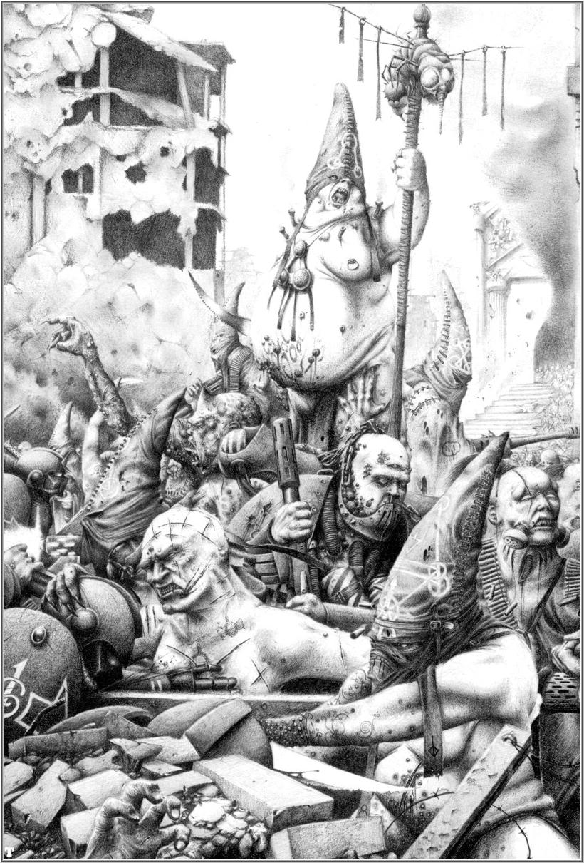

The Lost and the Damned is the name collectively given to the multitude of beings that have turned to Chaos over the millennia, the vast majority of whom are the ordinary mortals who fight for Chaos. They are not a single coherent force, but rather a diverse and infinite collection of warbands and hosts under the leadership of Chaos Champions. In order to fulfill their own agendas, Champions of Chaos draw lesser Chaotic followers to them. They form personal armies that can vary tremendously in size and strength. Often the Champion is a powerful demagogue, Apostate Confessor or Cardinal of the Ecclesiarchy, Traitor or Arch-Heretic. In some cases it is even a mighty Chaos Space Marine who has left his Traitor Legion or Renegade Chapter with his retinue of corrupted Astartes so that he may start his own warband and carve out his own dominion in the galaxy. During a Black Crusade, however, individual Chaos Champions will put aside their petty wars and rivalries for the common cause of Chaos Undivided and the Lost and the Damned form a nigh unstoppable tide that attacks with seemingly inexhaustible numbers.
. Lost and the Damned Special Rules

Advisor: Any model with the Advisor special rule, at the beginning of the game, must be placed in coherency with another unit numbering a minimum of 5 models. For all intents and purposes, the Advisor unit counts as a Squad Leader. This represents the fact while commanders such as Apostate Preachers or Enforcers are powerful; they are not so powerful as to strike out on their own. They would rather travel with an armed bodyguard. If the Advisor is the last remaining model in his unit, then they gain the Independent Character rule, until they move into coherency with another non-vehicle friendly unit.

Cursed Leadership: Though many of the soldiers among the ranks of the Lost and the Damned are fanatical cultists, too large to count are the numbers of civilians and PDF units forced onto the front lines for fear of brutal Enforcers and merciless Champions. Because of this large divide in the loyalty of Lost and the Damned infantry, for all units that have the Cursed Leadership special rule, and have their Ld. stat marked with an “*” roll a d6+4 at the beginning of any game, before deployment. Whatever total rolled is the Leadership value for that unit. Mark on a separate piece of paper these values. Where a score of 5 represents terrified civilians, a 10 represents a unit of fanatical cultist. In addition, any unit with a Vox Caster may reroll the Leadership value for the Cursed Leadership, at the beginning of the game.

Rivalry of the Gods: Models with this special rule are so devoted to their chosen Chaos God, that they would never consider even associating with the devotees of any other. Any Advisor or Independent Character with the Rivalry of the Gods special rule, and also equipped with a Chaos Icon can only join friendly units with the same Chaos Icon as themselves, or no Chaos Icon at all.

Slaves to Darkness: Having sworn both body and soul to the Chaos Gods, the Lost and the Damned have given up almost all of their humanity. Thus, death has lost much of its sting in their eyes. All units with the Slaves to Darkness special rules may reroll failed Morale checks to regroup, and may regroup when at less than 50% of their unit’s original size. Note: If an Advisor or Independent Character which has the Slaves to Darkness rule joins a unit that does not have the rule, the unit gains the Slaves to Darkness rule as long as they remains in the unit.

Traitors to Humanity: Hated by the Imperium of Mankind above all else, the Lost and the Damned spend much of their violent lives thrashing against the yoke of the Corpse God-Emperor. Any model from the Black Templars, Blood Angels, Dark Angels, Grey Knights, Imperial Guard, Sisters of Battle, Space Marines, or Space Wolves armies gains the Preferred Enemy USR against all Lost and the Damned models on the turn they Assault. However, this works both ways, and any Lost and the Dammed model gains the Preferred Enemy USR the turn it Assaults one of these armies.

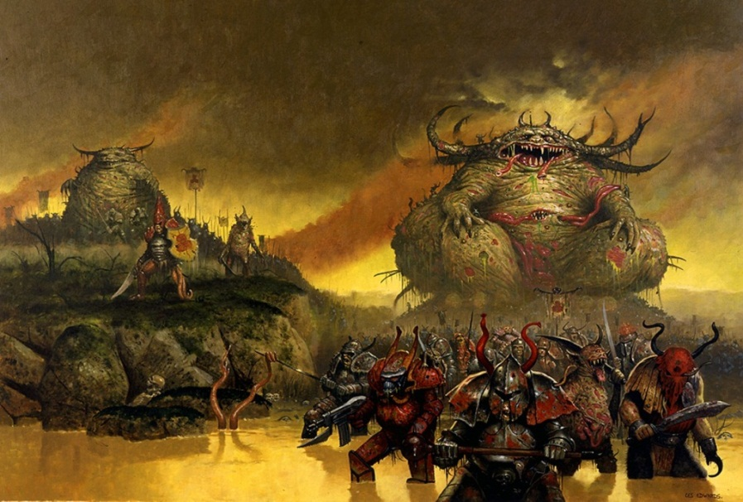
Nurgle’s Rot spreads contagion across the world, as legions of Footmen and Daemons march forward.
Lost and the Damned Occult Items

Book of Dekk: Dekk, a once great philosopher and judge of the Emperium of Mankind, was corrupted by chaos soon after Horus’s ascension to the powers of Darkness. He was well known for his innumerable scripts written and released to his subjects for distribution. Even before he succumbed to the Chaos powers, he wrote of the History of the Emperium and its creation. After his corruption, he began to write of the death and corruption of the Emperium, including horrifically detailed descriptions of its downfall. These books are treated as relics of the Lost and the Damned, handed down and collected with the utmost care and vindication. When these books are found, the Arch Heretic will scream Scriptures and Passages from these books, unsettling and terrifying the loyal soldiers of the Emperium. When a Lost and the Damned unit, carrying a Book of Dekk, is in an Assault involving a unit from the following armies: Blood Angels, Grey Knights, Imperial Guard, Sisters of Battle, Space Marines, or Space Wolves, the Arch Heretic is treated as carrying Defensive grenades. In addition, the enemy unit must make a Leadership check or Fall Back, so long as they suffer a single unsaved wound.

Chaos Banner: Often, an especially ambitious Champion creates his own flag to rally his troops, in a mockery of the Imperial Guard Standard Bearers. These are often grisly effigies, made of a combination of scavenged Imperial Guard regimental banners and bloody corpses. It is even believed that the banners hold chaos power, consecrated by their foul gods. Whatever their means of creation, the items are still horrific and vile, which nonetheless strengthen the chaos servants. In any Close Combat including a Lost and the Damned unit which has at least a single model within 12 inches of a Chaos Banner, the Lost and the Damned army adds +1 to combat resolution.

Formulae Injector: Formulae Injectors are the renegades’ response to the typical Imperium Medi-Pack. Because of their mutated frames and chaotic biology, standard methods of closing wounds and staunching blood flow will not work on them. Instead, the twisted “medics” available will mix together a virulent soup of chemicals, which, despite its ripe stench, will cause bleeding wounds to quickly scab or scar over. However, because of its limited quantities, this prized mixture is only carried by the strongest and most powerful of their commanders. A unit equipped with a Formulae Injector gains the Feel No Pain USR.

Ichor Chalice: An Ichor Chalice is a sophisticated container that holds the ruined body of an Imperium Sanctioned Psyker, killed in battle by the Arch Heretic. The Arch Heretic uses the constant flow of energy, leaking out of the intact brain and heart of the Psyker, to supplement his own fell power. An Arch Heretic carrying an Ichor Chalice may use two Psychic powers each turn instead of the normal single power.

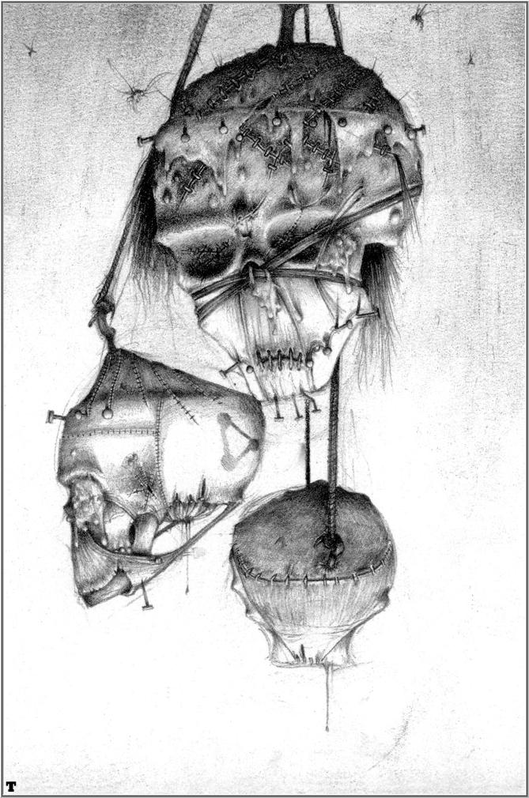
Oculus: An Oculus is the most dark and horrific item an Arch Heretic may carry, and only the most depraved and insane Arch Heretic would even attempt to create one. An Oculus is a Daemon in its own right, summoned and bound by a cabal of Psychics to an unholy crown. When worn, such is the extent to which this item is a stain to the living world, which little can stand in the way of its bearer. An Arch Heretic equipped with an Oculus may draw Line of Sight through any terrain, and any cover save made against his attacks are suffer a -1 modifier. In addition, any model in base contact with an Oculus equipped Arch Heretic suffers a Strength 4, AP 2 hit, at the beginning of every round of Close Combat.

Skull Totem: When an Arch Heretic creates a Skull Totem, he will behead one of his greatest enemies, desecrates the head with iron spikes, tears out the tongue, and flays the scalp from the bone. After the dark ceremony is complete, the Arch Heretic may release the emotions connected to the mutilated item to act as a beacon for summoned Daemons. Once per game, when a Daemonic unit enters the battlefield via Deep Strike, they may reroll the scatter dice to determine where the Daemons land.

Unholy Relic: At certain times, the Lost and the Damned are blessed with the presence of a Daemon Prince to lead them into battle. These towering beings are immensely powerful, and the Lost and the Damned flock to their side, frenzied by its sight. However, these creatures can be bested in combat, and when the unthinkable happens and the monstrosity is slain, it falls to the Apostate Preachers to scrap what little remains of the soldiers Morale. In doing so, totems and relics are made in representation of the fallen Daemons. Bones, horns, and scraps of flesh are collected, and then packed into iron-shod containers. These dark and vile reliquaries serve to fill the close-by soldiers with hatred and malice, to continue the attack. Once per game, a single friendly unit that Assaults an enemy within 12 inches of an Unholy Relic gains +d3 Attack instead of the normal +1 for Charging. There may only be a single Unholy Relic in any Lost and the Damned army.

Lost and the Damned Armory

Weapon | Range | Strength | AP | Special
Autocannon | 48” | 7 | 4 | Heavy 2
Autogun | 12” | 3 | 5 | Assault 2
Autopistol | 12” | 3 | 5 | Pistol
Auxiliary Grenade Launcher  (Frag)  (Krak) | 12” | 3  6 | 6  4 | Assault 1…  3” Blast
Battle Cannon | 72” | 8 | 3 | Ordinance 1, 5” Blast
Blastmaster  (Varied frequency)  (Fixed frequency) | 36”  48” | 5  8 | 4  3 | Pinning…  Assault 2  Heavy 1, 3” Blast
Bolt Pistol | 12” | 4 | 5 | Pistol
Bolt Gun | 24” | 4 | 5 | Rapid Fire
Demolition Charge | 6” | 8 | 2 | Assault 1, 5” Blast, One use
Flamer | Template | 4 | 6 | Assault 1, Ignores cover
Grenade Launcher  (Frag)  (Krak) | 24” | 3  6 | 6  4 | Assault 1…  3” Blast
Havoc Launcher | 48” | 5 | 5 | Heavy 2, 3” Blast, Twin-Linked
Hammer Pistol | 6” | 6 | 5 | Pistol
Heavy Bolter | 36” | 6 | 4 | Heavy 3
Heavy Flamer | Template | 5 | 4 | Assault 1, Ignores cover
Heavy Mortar | 12”-48” | 6 | 4 | Ordnance 1, Accurate, Barrage, 5” Blast
Heavy Stubber | 36” | 4 | 6 | Heavy 3
Immolator | 24” | 3 | 3 | Rapid Fire, Gets Hot!
Lascannon | 48” | 9 | 2 | Heavy 1
Lasgun | 24” | 3 | none | Rapid Fire
Laspistol | 12” | 3 | none | Pistol
Meltagun | 12” | 8 | 1 | Assault 1, Melta
Missile Launcher  (Frag)  (Krak) | 48” | 4  8 | 6  3 | Heavy 1…  3” Blast
Mortar | 12”-48” | 4 | 6 | Heavy 1, Barrage, 3” Blast
Multi-Laser | 36” | 6 | 6 | Heavy 3
Plasma Pistol | 12” | 7 | 2 | Pistol, Gets Hot!
Plasma Gun | 24” | 7 | 2 | Rapid Fire, Gets Hot
Reaper Autocannon | 36” | 7 | 4 | Heavy 2, Twin-Linked
Shotgun | 12” | 4 | 5 | Assault 2
Sonic Blaster | 24” | 4 | 4 | Assault 2 or Heavy 3, Pinning
Sniper Rifle | 36” | x | 6 | Heavy 1, Sniper
Head-Quarters

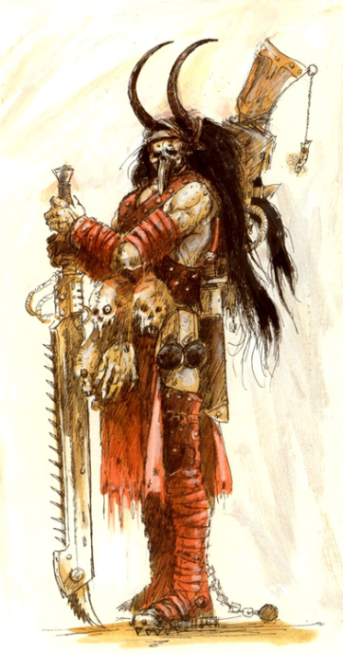
Arch Heretic
An Arch Heretic is the most commonly used name to describe any leader of a Chaos Renegade Legion. They are usually either the Planetary Governors of a Chaos inflicted world, or perhaps a Psyker who has accepted the advice and power of a Greater Daemon. Either way, they are one of the most dangerous leaders of the Lost and the Damned. They are often seen wielding fell energies, or carrying dark and daemonic items onto the field of battle. One aspect, however, that is true about these vile cultist, no matter their origin, is that their frenzied orations and battle-cries leads those of Chaos around them into a frenzy that can only be met with the Light of the Emperor. Arch Heretic are also commonly the leaders of Chaos cults. The objective of the Chaos Cult is to survive and eventually dominate the society in which it dwells. Mere survival is particularly important on Imperial worlds, where Chaos worship is the greatest of heresies and Inquisitors are always vigilant and ready to wipe out any taint of Chaos. Generally clandestine in nature, as discovery could bring with it attention from the local Adeptus Arbites continent all the way up to the Inquisition, cults often hide behind the front of some form of legitimate Imperial organization in their attempt to accumulate local or planetary power, such as trade unions, charitable organizations, accepted religious groups and even local variants of the Imperial Cult. Thus, while any Arch Heretic may be a powerful warrior or Psyker, or just a Chaos affiliated commander, or businessman. This makes the discovery of such cults all the more difficult to discover and destroy.

Points | Ws | Bs | S | T | Wounds | I | A | Ld. | Sv.
75 | 5 | 4 | 4 | 4 | 3 | 3 | 2 | 10 | 4+

- Unit Composition: 1x Arch Heretic
- Wargear: Bolt Pistol, Carapace Armor, Chainsword, Frag and Krak grenades
- Special Rules: Independent Character, Rivalry of the Gods, Slaves To Darkness, Traitors to Humanity
  - Alpha Level Psyker - The Arch Heretic may be a dangerous Psyker. As such, he may purchase psychic powers from the options listing. Any psychic powers purchased make the Arch Heretic a Psyker. Note that while the Arch Heretic may purchase any number of psychic powers, he may only use one per turn.
  - Demagogue - Such is the power of the Arch Heretic’s constant oration that he instills total devotion in those around him. The Arch Heretic can make a Leadership check at the start of his turn, and if this is passed then a single non-vehicle friendly unit within 12 inches of the Arch Heretic automatically succeed on any Leadership check they are called on to make, until the following player turn.
- Options:
  - The Arch Heretic may carry an Icon of the Chaos Gods:
    - Khorne (+1 Attack)…15 points
    - Nurgle (+1 Toughness, except for Instant Death)…20 points
    - Slaanesh (+1 Initiative)…15 points
    - Tzeentch (+1 Invulnerable save, or 5+)…20 points
  - The Arch Heretic may replace his Bolt Pistol with:
    - Autogun or Shotgun…free
    - Sniper Rifle or Bolt Gun…5 points
    - Attach an Auxiliary Grenade Launcher to any weapon…10 points
    - Plasma Pistol…15 points
  - The Arch Heretic may replace his Chainsword with:
    - Power Sword…10 points
    - Power Fist…15 points
    - Eviscerator…25 points
  - The Arch Heretic may take any of the following:
    - Melta Bombs…5 points
    - Power Armor…10 points
    - Refractor Field…15 points
  - The Arch Heretic may take any of the following Psychic Powers:
    - Gore Burst…10 points
    - Soul Rupture…10 points
    - Exultus…15 points
    - Desecration…25 points
    - Touch of the Warp…35 points
    - Dance of the Puppet…35 points
  - The Arch Heretic may any of the following Occult Items:
    - Skull Totem…5 points
    - Book of Dekk…15 points
    - Formulae Injector…20 points
    - Ichor Chalice…25 points
    - Oculus…55 points

Arch Heretic Psychic Powers
Gore Burst - Focusing his will through the storms of the warp, an Arch Heretic can literally rip a living being inside-out, creating a puddle of putrid flesh. The backlash of such powerful wizardry has its benefits as well, and the release of pent-up energy will cause the same effect in other beings that stray too close. This power is a Psychic shooting attack, using the following profile:

Range | Strength | AP | Special
18 | 6 | 5 | Assault 1

For every unsaved wound caused by this attack, the target unit suffers another “secondary” hit. For every unsaved wound caused by a secondary hit, the unit suffers another secondary hit. This continues until there are no more secondary hits caused, or the target unit has been completely destroyed.

Soul Rupture – The Arch Heretic lashes out with psychic energies, as torrents of unholy lightning tear forth from his eyes and outstretched arms. The blasts of energy ground themselves into the enemy, reducing flesh to ash and bones to fragments. However, such energy is difficult to control, and will fly into both allies and enemies with little concern. This is a Psychic shooting attack, with the following profile:

Range | Strength | AP | Special
18 | 5 | - | Assault 2d6

Every time this power is used, roll a d6. On a roll of 6, the attack counts as AP 3. On a roll of 1, the attack must also be made on a friendly Lost and the Damned unit within 24 inches of the Arch Heretic. If there is no friendly unit within range, then make the attack against the Arch Heretic himself.

Exultus - On a successful psychic test, the Arch Heretic infuses his allies with a portion of his power, causing them to rush towards their enemies in a murderous rage. All friendly non-vehicle models within 12 inches may immediately move d6 inches. Treat this movement as a Consolidation move, in all respects. This power must be activated during the Movement phase, but made in addition to any normal moves. Any affected units fire their weapons in the Shooting phase as though they had moved, but not run.

Desecration - After the Arch Heretic is on the winning side of a Close Combat, or causes an enemy unit to fall back for any reason, he may make a Psychic test. If successful, the enemy unit is torn to pieces by vile energies, as bolts of pure darkness rip into flesh and bone. The target unit must immediately make a Leadership test, on its unmodified Leadership. If the Leadership test is failed, the unit is destroyed completely, with no saves of any kind allowed.

Touch of the Warp - A powerful Arch Heretic has the ability to completely corrupt an enemy to Chaos. Upon successful Psychic test, the Arch Heretic may select an enemy unit within 24 inches. Roll a 2d6, and the unit must make that many toughness tests. For every failed test, the unit suffers a single wound with no Armor or Cover saves allowed. If this attack destroys the unit, then place a number of Chaos Mutants equal to the number of wounds inflicted within an inch of where the unit stood before it was destroyed. These models are placed in play as though they had just Deep Striked into that exact area, and cannot be placed within an inch of an enemy model. If these parameters cannot be met, then no Chaos Mutants are created. To note, these models are treated as a unit in their own right, and must remain in Coherency. See the Troops section for more information on Chaos Mutants.
(Note: Invulnerable saves may still be rolled against wounds caused by this power. Independent Characters killed in this manner do not create any Chaos Mutants.)

Dance of the Puppet – Laughing with malicious glee, the Arch Heretic forces his way into the minds of his enemies, to control their every action. Under his vile control, friends turn against friend in a bloodbath for swirling combat. This Psychic Power is used in the Assault Phase. Select an enemy unit within 18 inches, even one that is locked in Close Combat. Resolve a round of Close Combat out made by the unit against itself, out of sequence. The Arch Heretic may choose which Close Combat weapon they use if there is a choice. All of these attacks roll To Hit versus their own Weapon Skill and To Wound against their own Toughness. The unit can then fight in Close Combat as normal, if applicable.

Aspiring Champion’s Legion
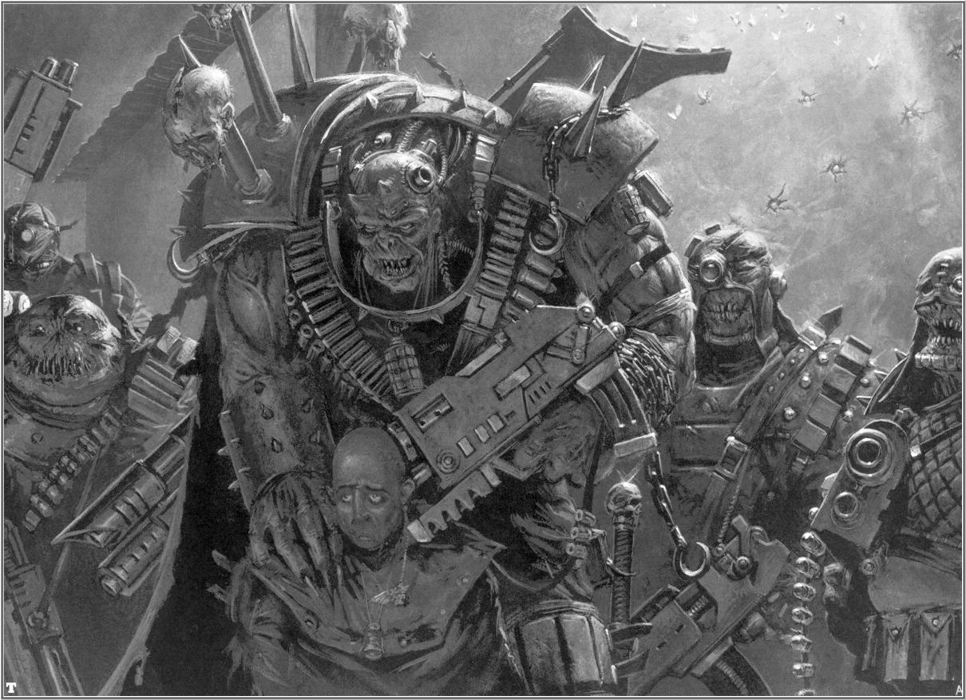
There are instances, when an Arch Heretic or Chaos Lord is not present to lead the rabble that is the Lost and the Damned, a Champion of great ambition and prestige will ascend to command the army. They are, in general, not powerful enough to strike out on the battlefield by themselves, and will instead surround themselves with their most loyal and devoted followers. Equipped with stolen weaponry and equipment, the now “Aspiring” Champion will lead the remains of the horde onwards into war against their numerous enemies.

Points | Ws | Bs | S | T | Wounds | I | A | Ld. | Sv. | Unit
85 | 4 | 4 | 4 | 4 | 3 | 3 | 3 | 10 | 5+ | Aspiring Champion
-- | 3 | 4 | 3 | 3 | 1 | 3 | 1 | 8 | 5+ | Disciples
20 per | 3 | 3 | 3 | 3 | 2 | 3 | 2 | * | 5+ | Weapon Teams

- Unit Composition: 1x Aspiring Champion, 4x Disciples, 0-3 Weapon Teams
- Wargear:
  - Aspiring Champion: Bolt Pistol, Chainsword, Flak Armor
  - Disciple: Autogun, Chainsword, Flak Armor
  - Weapon Teams: Laspistols, Flak Armor, Heavy Stubber
- Special Rules: Slaves To Darkness, Traitors to Humanity
  - Attached Weapon Teams only: Cursed Leadership
  - Blood of Horus - It is rumored, but not proven, that the Champions draw lineage back to the great and powerful Horus. There is the possibility that Horus collected his own Gene Seed and replicated it for this very purpose. Whether or not this is the reality matters little, because the Champions do indeed share his supernatural resilience. All Champions are immune to the effects of Instant Death from a wound with Strength double their Toughness. They can still be instantly killed by a Force Weapon or other effect, though.
  - Dark Ambition - Such is the extent of the Aspiring Champions ambition to overcome all obstacles, which he will throw himself at the greatest foe he can find on the battlefield. An Aspiring Champion gains Furious Charge USR, when entering an assault into base contact with an enemy Psyker, Squad Leader, or Independent Character.
  - Gaze of Vindiction - Champions are among the greatest and most frightening warriors the Lost and the Damned can call upon, and thus their subordinates look up to them in awe and terror. His subordinates would never even consider the possibility of fleeing in the Champion’s view. All friendly units within 6 inches of the Legion must reroll failed Pinning Tests and Moral tests caused by Tank Shocking or being on the losing side of Close Combat.
- Options:
  - The Aspiring Champion may carry an Icon of the Chaos Gods for his unit:
    - Khorne (+1 Attack)…15 points
    - Nurgle (+1 Toughness, except for Instant Death)…15 points
    - Slaanesh (+1 Initiative)…15 points
    - Tzeentch (+1 Invulnerable save, or 5+)…20 points
  - The Aspiring Champion may replace his Bolt Pistol with:
    - Shotgun…free
    - Hammer Pistol…2 points
    - Sniper Rifle or Bolt Gun…5 points
    - Plasma Pistol…15 points
  - The Aspiring Champion may replace his Chainsword with:
    - Mutant Weapon (+2 Strength in Close Combat)…5 points
    - Power Sword…10 points
    - Power Fist…20 points
  - The Aspiring Champion may take any of the following:
    - Melta Bombs…5 points
    - Power Armor…10 points
    - Refractor Field…15 points
  - One Disciple may carry a Chaos Banner…15 points
  - One Disciple may carry a Dirge Caster…15 points
  - Any remaining Disciple that has not already been given one of the above upgrades may carry a:
    - Flamer or Grenade Launcher…5 points
    - Meltagun…10 points
    - Plasma Gun…15 points
  - The entire squad may take Carapace Armor…25 points
  - The entire squad may carry Frag and Krak grenades…10 points
  - Each Weapon Team may replace its Heavy Stubber with:
    - Mortar or Heavy Flamer…free
    - Heavy Bolter, Autocannon, or Havoc Launcher…5 points
    - Missile Launcher…10 points
    - Lascannon…15 points

Mutant Superior
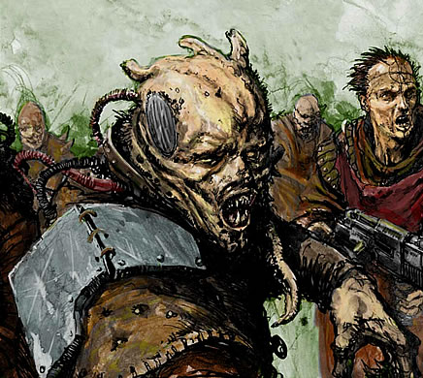
A Mutant Superior is the ultimate in chaotic transformation. Their bloated and twisted forms hold inside them massive strength and endurance, unlike anything natural. Their relentless power outweighs even a mighty Space Marine, and the swollen creatures will tear even Astartes to pieces in moments. On the battlefield, Mutant Superiors will either rush into Close Combat with a combination of horrific claws and tentacles; or use their great strength to carry heavy weapons onto the frontlines, where otherwise a team of Renegades would be required. In each case, they accompany hordes of mutated rabble, who draw inspiration from the aberration. It is worth noting, that unlike the other leaders of the Lost and the Damned, Mutant Superiors do not always pray to a Chaos God. This is perhaps, because not all of these creatures have been created by the mutations of Chaos.

Points | Ws | Bs | S | T | Wounds | I | A | Ld. | Sv.
35 | 3 | 2 | 4 | 5 | 2 | 2 | 4 | 8 | 6+

- Unit Composition: 1x Mutant Superior
- Wargear: Autopistol, Chainsword, Scrap Armor
- Special Rules: Independent Character, Slaves to Darkness, Traitors to Humanity
  - Abhorrent Leadership: The Mutant Superior is a horrific monstrosity to behold, and because of this, any being looking upon it is filled with revulsion. As if by instinct, the Mutant Superiors lurk among their own kind, other creatures as vile as themselves. A Mutant Superior may only join units of Chaos Mutants, Ghasts, Traitors, or Lesser Daemons. However, when the Mutant Superior joins one of these units, they gain the Stubborn USR.
  - Rampage: Mutants have bloated bodies and stunted legs, which are not well suited to fast movement. However, the creatures’ rapid ferocity more than makes up for the fact. All Mutants have the Slow and Purposeful USR; however, when moving or assaulting they roll 2d6 and choose the higher result. In addition, all Mutants have a 6+ Invulnerable save to represent their altered biology and twisted frame.
- Options:
  - The Mutant Superior may carry a Chaos Icon:
    - Khorne (+1 Attack)…20 points
    - Nurgle (+1 Toughness, except for Instant Death)…20 points
    - Slaanesh (+1 Initiative)…15 points
    - Tzeentch (+1 Invulnerable save, or 5+)…25 points
  - The Mutant Boss may replace his Chainsword with:
    - Mutant Weapon (+2 Strength in Close Combat)…5 points
    - Eviscerator…25 points
  - The Mutant Superior may take one of the following:
    - Flamer, Grenade Launcher, or Heavy Stubber …5 points
    - Havoc Launcher, Heavy Bolter, or Heavy Flamer…10 points
  - May take any of the following:
    - Dirge Caster…15 points
    - Formulae Injector…20 points
  - Replace Scrap Armor with Carapace Armor…5 points
  - May carry Frag grenades…2 points
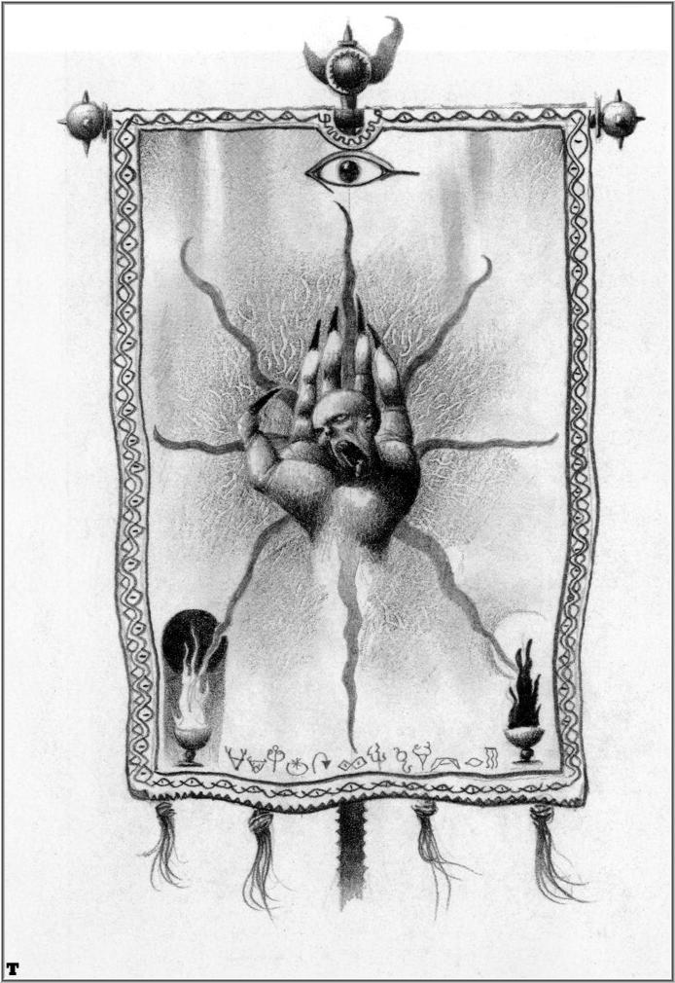
A Chaos Banner captured after the rebellion on Hephastion IV
Cultists
A Cultist is the title given to the officers and lieutenants of a Lost and the Damned army, the priests, the prophets, and the leaders of the occult. They are not the true commanders of the Legions, only those important enough to be given notice among the rank and file. All Cultists have the Advisor rule listed earlier in the Special Rules section of the codex. Cultists count as units for the HQ section of the Force Organization chart, but do not actually take up any slot. They are merely additions to an army.

0-3 Apostate Preacher
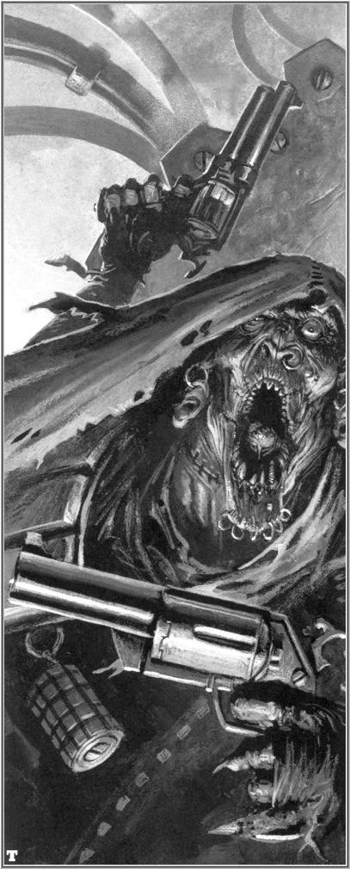
Ministorum Priests, Tech-priests, and Acolytes who turn to Chaos often become Apostate Preachers. These fallen clergy are driven insane by the turmoil of their faith to the God-Emperor of Man, and the power of Chaos Gods, such that when all is said and done they are little more than screaming hierophants, slaves to the Gods of corruption. There vile call is answered by the innumerable hordes, which follow these dark priests in their unholy congregation. Often seen on the field of battle, either leading ragtag bands of renegades, to even following in the wake of Daemons, great and small. It is believed that the Apostate Preachers serve as a torch, to guide the Warp-spawn to the material realm, but as of yet little has been ascertained. They are, in general, considered very dangerous by the Inquisition. Extreme caution is to be used in a confrontation with one of these gibbering fiends, for even their unholy annunciations can drive the weak or corrupt to Chaos.

Points | Ws | Bs | S | T | Wounds | I | A | Ld. | Sv. | Unit
35 | 3 | 3 | 3 | 3 | 1 | 3 | 2 | 10 | 5+ | Apostate Preacher

- Unit Composition: 1x Apostate Preacher
- Wargear: Chainsword, Flak Armor, Laspistol
- Special Rules: Advisor, Fearless, Slaves to Darkness, Traitors to Humanity
  - Battle Fury: The Apostate Preacher, in the middle of the battle, will scream dark passages and occult sermons at the top of his lungs, often accompanied by a Megaphone or Vox Caster. His vile call reinforces the will of his followers, and their ferociousness. All models in the same unit as the Apostate Preacher gain the Preferred Enemy and Fearless USR, so long as the Preacher still lives.
  - Fanatical: While the orations of the Apostate Preacher do strengthen his allies’ combat prowess, they also drive them to insane acts of destruction. In the Assault Phase, a unit including an Apostate Preacher as an Advisor must initiate an Assault, if possible. In addition, the unit suffers from the Rage USR as long as the Preacher lives.
- Options:
  - The Preacher may take a Chaos Icon:
    - Khorne (+1 Attack)…15 points
    - Nurgle (+1 Toughness, except for Instant Death)…20 points
    - Slaanesh (+1 Initiative)…15 points
    - Tzeentch (+1 Invulnerable save, or 5+)…20 points
  - The Preacher may replace his Laspistol with:
    - Bolt Pistol or Shotgun…2 points
    - Hammer Pistol…5 points
      - Dual wielded Hammer Pistols (counts as Twin-Linked)…+5 points
    - Plasma Pistol…10 points
  - The Preacher may replace his Chainsword with:
    - Power Weapon…10 points
    - Eviscerator…20 points
  - The Preacher may carry one Occult Item:
    - Skull Totem…5 points
    - Book of Dekk…15 points
    - Unholy Relic (Only one per army)…35 points
  - The Preacher may take any of the following:
    - Carapace Armor…5 points
    - Frag and Krak grenades…5 points
    - Refractor Field…15 points

0-5 Enforcers
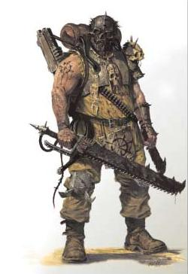
The Enforcers were originally Commissars and Officers of Imperial Garrisons and PDF units, but when the touch of Chaos took them, the changed their ways and turned to the darkness of the gods. The first point in time when the Enforcers were seen on the battlefield was on Vraks, servants to the mad Cardinal Xaphan. They serve as commanders and task-masters, keeping the Renegades moving and in order. Their control has no limits, and they show little mercy for those who do not fight. It has been seen many times across the Multiverse when an Enforcer will simply strike down his entire squad to keep the rest from fleeing. Their insane devotion and depravity does not seem to peak, or hold any moment of reflection.

Points | Ws | Bs | S | T | Wounds | I | A | Ld. | Sv. | Unit
35 | 4 | 3 | 4 | 4 | 1 | 4 | 2 | 10 | 5+ | Enforcer

- Unit Composition: 1x Enforcer
- Wargear: Flak Armor, Laspistol, Frag and Krak grenades, Power Weapon
- Special Rules: Advisor, Rivalry of the Gods, Slaves To Darkness, Traitors to Humanity
  - Enforce Order: The task of the Enforcer is to ensure that no matter the conditions, the troops of the Lost and the Damned remain loyal to their leaders. This will be done with the utmost ruthlessness and no mercy, as the Enforcers go about rooting out cowardice with malicious glee. Whenever a unit with an Enforcer fails a Leadership check, immediately remove d6 models from the unit, as the Enforcer rampages about restoring order. The unit may then reroll the check, subtracting the number of models removed from the final value. If the unit numbers less than 5x models, not including the Enforcer, then the Enforcer cannot use the Summary Execution ability.
Note: The Lost and the Damned player must remove all other models before removing a Squad Leader or Weapon Bearer as a result of the Enforce Order rule.
- Options:
  - The Enforcer may take a Chaos Icon:
    - Khorne (+1 Attack)…15 points
    - Nurgle (+1 Toughness, except for Instant Death)…20 points
    - Slaanesh (+1 Initiative)…15 points
    - Tzeentch (+1 Invulnerable save, or 5+)…20 points
  - The Enforcer may replace his Laspistol with:
    - Autogun, Bolt Pistol, or Shotgun…2 points
    - Slugger…5 points
    - Plasma Pistol…10 points
  - The Enforcer may replace his Power Weapon with:
    - Poisoned Weapon (CC weapon, wounds on a 2+)…5 points
    - Power Fist…15 points
  - The Enforcer may take any of the following:
    - Carapace Armor…5 points
    - Melta Bombs…5 points
    - Refractor Field…15 points
    - Demolition Charge…15 points

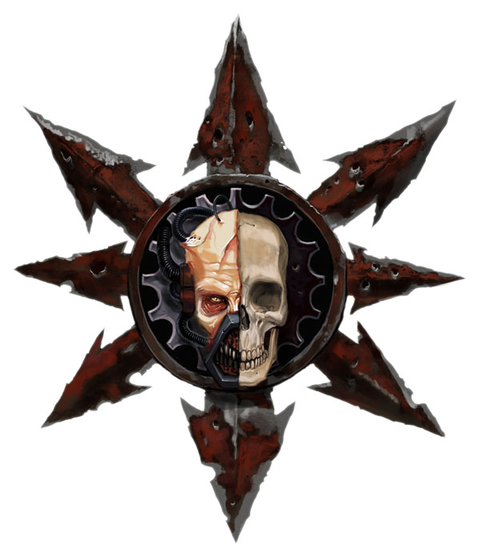
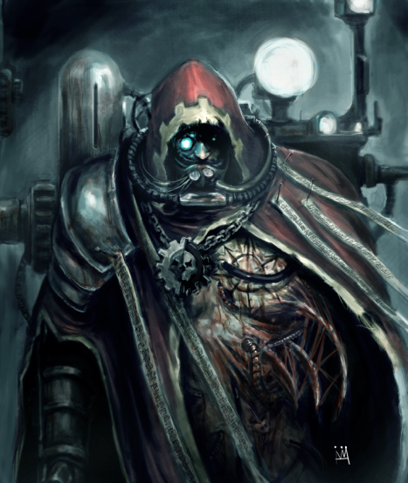
0-3 Heretek
Heretek is the name given by the Adeptus Mechanicus to those Tech-priests who turn their backs on the teachings and strictures of the Cult Mechanicus, in pursuit of dark and forbidden technologies linked to the power of the Warp, and the Ruinous Powers of Chaos. Hereteks value the pursuit of knowledge, at all costs, regardless of the consequences to themselves or to others and even at the peril of their own souls. Many Hereteks are loosely connected to the Dark Mechanicus, those members of the Priesthood of Mars who turned their backs upon the Emperor of Mankind during the Horus Heresy and swore to serve the Warmaster Horus and the Dark Gods in return for technological advancements denied them by the Emperor for the safety of Mankind. Others, however, pursue the dark path of tech-heresy completely on their own, forging their own roads to damnation independent of any direct connection to Chaos or the Dark Mechanicum, though still wholly in violation of the strictures of the Cult of the Machine God.
Points | Ws | Bs | S | T | Wounds | I | A | Ld. | Sv. | Unit
35 | 2 | 3 | 3 | 4 | 1 | 2 | 2 | 9 | 3+ | Heretek

- Unit Composition: 1x Heretek
- Wargear: Laspistol, Integrated Daemon Biology, Power Armor, Servo-Arm
- Special Rules: Advisor, Slaves To Darkness, Traitors to Humanity
  - Corruption of the Machine Spirit: While a normal Tech-priest or Engine-seer who serves the Machine Spirit by repairing and creating, a Heretek does sees this to be a perversion of his talents, be they to create, or destroy, and the Machine Spirit be damned! A Heretek, while within base contact of a friendly vehicle, may remove an Immobilized or Weapon destroyed result on a 4+ during the Shooting Phase. In addition, the Heretek and his unit may reroll failed Leadership checks caused by Tank Shocking.
  - Integrated Daemonic Biology: A Heretek is free from the restraints normally in put in place by the Cult Mechanicus, not concerning the integration of mechanical augmentations, but more so the use of biological ones. Hence, the Heretek is covered with both mechanical attachments and, in more severe cases, grafted daemon flesh. This drastically improves the endurance of the Heretek, and as such, a 5+ invulnerable save.
  - Servo-Arm: A Heretek still carry with them the remains of their old equipment and repair tools, thus, the almost always are equipped with the massive servo-powered arms reminiscent of the servants of Mars. These heavy and cumbersome tools are primarily used for repairs and construction, but will serve well to pulp enemies in Close Combat. In addition to the normal attacks of a Heretek, they receive a single Servo-Arm attack that is resolved at Initiative 1, using the Weapon Skill of the Heretek. This attack is Strength 8, and ignores all armor saves.
- Options:
  - The Heretek may replace his Laspistol with:
    - Autogun or Shotgun…free
    - Hammer Pistol…5 points
      - Dual wielded Hammer Pistols (counts as Twin-Linked)…+5 points
  - The Heretek may take any of the following:
    - Melta Bombs…5 points
    - Power Weapon…10 points

0-5 Renegade Psyker
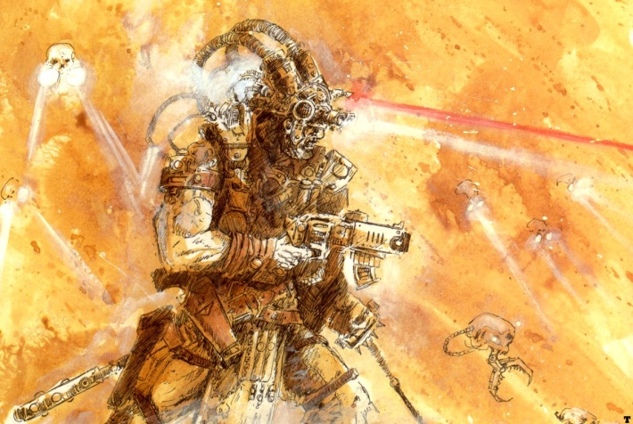
The Renegade Psykers are the servants of the Chaos Gods, former priests, overseers, and Psykers who the Gods have seen fit to empower. This is a blessing that comes to only the farthest gone, the most depraved, and those of the most worth. However, this vile gift is not without a cost, as the moment the Chaos Gods are finished with their servants, their souls are tossed aside. Yet, the power these damned mortals wield is great, and by no means should they be challenged without the utmost care and caution.

Points | Ws | Bs | S | T | Wounds | I | A | Ld. | Sv. | Unit
35 | 3 | 3 | 3 | 3 | 1 | 3 | 1 | 8 | 5+ | Renegade Psyker

- Unit Composition: 1x Renegade Psyker
- Wargear: Stave, Flak Armor, Laspistol
- Special Rules: Advisor, Rivalry of the Gods, Slaves To Darkness, Traitors to Humanity
  - Chaotic Psyker: The Renegade Psyker counts as a Psyker. At the beginning of each Lost and the Damned turn, roll on the following table to represent the influx of power granted by the Chaos Gods. Whatever is rolled is the only power available to the Psyker that turn. Always roll for the Power before making any Psychic tests.
  - Vessel of the Gods: A Renegade Psyker’s mind has been completely and wholly corrupted by the glamour of Chaos, and as such they are living conduits of horrific energies. As such, all Renegade Psykers have a 5+ Invulnerable save. However, if the Renegade Psyker ever suffers the Perils of the Warp effect, the resulting energies are catastrophic. Center the large blast template over the Renegade Psyker, and all models underneath take a Strength 5, AP - hit.
- Options:
  - The Renegade Psyker may take a Chaos Icon:
    - Khorne (+1 Attack)…15 points
    - Nurgle (+1 Toughness, except for Instant Death)…20 points
    - Slaanesh (+1 Initiative)…15 points
    - Tzeentch (+1 Invulnerable save, or 5+)…20 points
  - A Renegade Psyker may replace his Stave with:
    - Power Weapon…10 points
    - Force Weapon…20 points
  - A Renegade Psyker may take any of the following:
    - Carapace Armor…5 points
    - Dirge Caster…15 points

Renegade Psyker Psychic Powers
Die Roll | Power
1 | Blessing of the Gods: The power of the Chaos Gods flows through the Psyker, a protective shroud of energy wreathes him and those close by. All friendly units within 12 inches gain a 5+ Invulnerable save.
2 | Proclamation of Terror: The Renegade Psyker begins to chant and scream, roaring out strings of ancient languages and forbidden knowledge. His words take flight, and lodge into the minds of the pure, sowing dissent and horror. This power is used at the beginning of the Shooting Phase. Until the beginning of the next friendly player turn, all successful Leadership checks made by enemy units within 18” of the Renegade Psyker must be rerolled.
3 | Horrific Visage: Calling upon terrible energies, the Renegade Psyker transforms his shape into that of a twisted monstrosity, horrifying and disgusting all who lay eyes upon him. In his presence, weaker mortals cower in fear. This power is used at the beginning of Assault phase. Until the beginning of the next friendly turn, any enemy in Close combat with the Renegade Psyker’s unit must succeed on a Leadership check or have their Initiative reduced to 1.
4 | Call of the Warp: The Renegade Psyker releases a torrent of psychic bolts, turning flesh to ash and bone to dust. Merely a single touch from the daemonic energies is enough to destroy even the greatest of warriors, or melt the wrought steel of the Emperium to slag. This power is a Psychic shooting attack, using the following profile:
  Range | Strength | AP | Special
  18” | 6 | - | Assault 3
5 | Hell’s Judgment: With a cry, the Renegade Psyker tears open a hole in the warp, releasing the gibbering spawn of the Chaos realms. While these creatures do not last long before they must slither back to their twilight realms, their anger is quite real, and they can inflict horrific damage before they are either forced back through the portal or slain. This power is a Psychic shooting attack, using the following profile:
  Range | Strength | AP | Special
  12” | 3 | 5 | Heavy 1, 5” Blast, Pinning, Poisoned 4+
6 | Thrall of Chaos: Some Renegade Psykers have given themselves completely to their chosen god, be it Khorne, Nurgle, Slaanesh, or Tzeentch. Any Renegade Psyker with an Icon of a Chaos God may, instead of rolling on the table, use a Psychic Power from the Codex: Chaos Space Marines. They may only use the power that matches the Chaos God of their Icon. If this power is rolled by a Renegade Psyker without a Chaos Icon, they must roll again until they get a result other than 6.

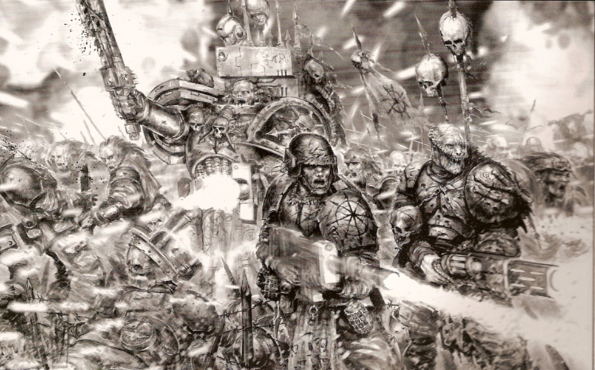
An Aspiring Champion leads a horde of Chaos Cultists and Guardsmen on an attack of an Imperial Forge World.

~~~~~~~~~~~~~~~~~~~~~~~~~~~~~~~

Khorne destroys, Slaanesh takes,
Nurgle infects and Tzeentch makes.
This world is ours; resistance is your fool’s errand,
All your hope abandoned.
Fear not mortals…be terrified.
-Carving found planetside of a Chaos World
Elites

Adherents of the Path
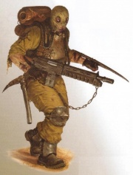
Adherents are those Renegades who are so devoted to their leaders and the Chaos Gods that they are gifted with superior weaponry and equipment. They are noticeable more skilled in combat than their lesser allies. Often, these soldiers have been observed by Imperial Officers being led by a commander known as a “Prelate”. What exactly the purpose of these leaders is still remains to be discovered. It has, however, been theorized that they act as religious leaders and spies, to ensure the Adherents remain as fanatical as ever. In either case, these commanders have (in general) undisputable knowledge of the lay of the surrounding terrain. Because of this the Disciples have become adept at launching ambushes from behind cover and rubble upon unsuspecting Imperial soldiers. They often carry older, decommissioned rifles colloquially known as “Immolators”. These vicious weapons appear similar to lasguns, but their muzzles belch out a concentrated stream of molten glass, which burns and sizzles through even the toughest armor.

Points | Ws | Bs | S | T | Wounds | I | A | Ld. | Sv. | Unit
+15 | 3 | 4 | 3 | 3 | 1 | 3 | 2 | 9 | 4+ | Prelate
10 per | 3 | 4 | 3 | 3 | 1 | 3 | 1 | 8 | 4+ | Adherent
Na. | 3 | 4 | 3 | 3 | 2 | 3 | 2 | 8 | 4+ | Weapon Team

- Unit Composition: 5-10x Disciples
- Wargear: Carapace Armor, Frag grenades, Immolator, Combat Knives
- Special Rules: Infiltrate (Only if the unit includes a Prelate)
- Options:
  - One Disciple may be upgraded to a Prelate…16 points
  - The Prelate may replace his Immolator with a:
    - Bolt Pistol or Hammer Pistol…free
    - Sniper Rifle…5 points
    - Plasma Pistol…10 points
  - The Prelate may replace his Combat Knife with a:
    - Power Weapon…10 points
    - Power Fist…15 points
  - The Prelate may carry one of the following:
    - Melta Bombs…5 points
    - Demolition Charge…15 points
  - Two Disciples may replace their Hellgun with a:
    - Flamer or Grenade Launcher…5 points
    - Melta Gun…10 points
    - Plasma Gun…15 points
  - Two Disciples may form a Weapon Team armed with:
    - Heavy Flamer or Heavy Stubber…5 points
    - Heavy Bolter or Missile Launcher…10 points
  - One Disciple may have a Dirge Caster…15 points
  - The entire squad may take Krak grenades…1 point/model

0-1 Alpha Legion
It is not unknown to the members of the Emperium of Mankind, that several, if not many, Chapters of Space Marines have gone rogue and entered the cults and followings of the Chaos Gods. The majority of these traitors are seen acting individually, as agents of the Dark Gods. However, it is not uncommon to see these hulking warriors following after scores of pox-ridden cultists, serving as shock troops and line breakers. They are deadly foe and should be feared in their own right.

Points | Ws | Bs | S | T | Wounds | I | A | Ld. | Sv. | Unit
+20 | 4 | 4 | 5 | 4 | 1 | 4 | 3 | 10 | 3+ | Centurion
18 per | 4 | 4 | 4 | 4 | 1 | 4 | 1 | 9 | 3+ | Legionnaire

- Unit Composition: 5-15x Legionnaires
- Wargear: Boltguns, Chain-Axes, Power Armor, Frag and Krak grenades
- Special Rules: Fearless, Slaves To Darkness, Traitors to Humanity
- Options:
  - One Legionary may be upgraded to a Centurion...25 points
  - The Centurion may replace his Boltgun with a:
    - Plasma Pistol
  - The Centurion may replace his Chain-Axe with:
    - Power Weapon...10 points
    - Power Fist...25 points
  - The Centurion may take Melta Bombs...5 points
  - One Legionnaire may replace his Boltgun with:
    - Flamer, Missile Launcher, or Heavy Bolter...5 points
    - Plasma Rifle, Autocannon, or Meltagun...10 points
    - Lascannon...15 points
  - One Legionnaire may carry a Chaos Icon:
    - Khorne (+1 Attack)...+25 points
    - Nurgle (+1 Toughness, except for Instant Death)...+35 points
    - Slaanesh (+1 Initiative)...+25 points
    - Tzeentch (+1 to Invulnerable save, or 5+)...+50 points
  - The entire squad may carry a Bolt Pistols...3 points each

Victims of the Warp
The Imperium of man is host to massive numbers of prison worlds, each full to the brim with the scum and villainy of the Hive Worlds. Often, the prisoners are pulled out to serve as auxiliary and dispensable infantry on the battlefield. However, prison riots are not uncommon, and many of these bloodthirsty villains would rather try their luck by themselves than serving some crazed Commissar. All too soon, the newly armed “Penal Legions” will turn on their officers, murder them, and flee the planet. Hordes of these traitors retreat to the only place the Imperium will not follow them: the warp. There they are subject to the greater daemons and beats that lurk there, and inevitably return to the known multiverse twisted and mutated, serving under some great overlord.

Points | Ws | Bs | S | T | Wounds | I | A | Ld. | Sv. | Unit
+12 | 4 | 2 | 3 | 3 | 1 | 3 | 3 | 8 | 6+ | Gang Boss
8 per | 4 | 2 | 3 | 3 | 1 | 3 | 2 | 7 | 6+ | Convict

- Unit Composition: 10+ Escaped Convicts
- Wargear: Broken Clubs and Knives, Frag grenades, Hammer Pistols, Scrapped Armor
- Special Rules: Furious Charge, Traitors to Humanity, Slaves to Darkness
  - Nothing Left to Lose: All convicts who have ever been able to break free from the massive prison worlds that ring throughout the Imperium know that they will never be able to return to a normal existence again. Because of this, the grand majority fled into the warp, when they could, seeking out an existence in the cruel dangerous of other outcasts. When they return, having witnessed and survived all the horrors the chaos worlds have to offer, they have no more fear of death, in fact, some even seek it. Escaped Combats always succeed on Morale checks caused by being on the losing side of a Close Combat. In addition, they always suffer wounds from the No Retreat! rule.
- Options:
  - One Convict may be upgraded to a Gang Boss…+15 points
  - The Gang Boss may take one of the following:
    - Mutant Weapon (+2 Strength in Close Combat)…5 points
    - Power Sword…10 points
  - The entire squad may take Krak grenades…1 point/model

Ogryn Bezerkers
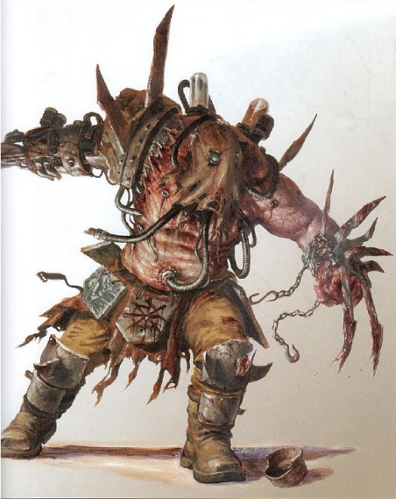
Ogryn Berserkers are Ogryns corrupted by Khornate Chaos Warbands, driven insane by bloodlust and evolving into ferocious and bloodthirsty beasts. Similar to Khorne Berserkers, these creatures were lobotomized and injected with a powerful combat drug known as "Slaught". Once Slaught is introduced into the bloodstream, the Ogryn becomes a raging psychopath. The downside of this treatment is the drug-fueled rampage cannot be sustained by the Ogryn's body and complete organ failure is an inevitable result of prolonged combat by Ogryn Berserkers. Ogryn Berserkers are known to be surgically modified by their masters in order to create a more potent killing machine. These include surgically removing limbs and replacing them with blades, buzz-saws, or other vicious weaponry.

Points | Ws | Bs | S | T | Wounds | I | A | Ld. | Sv. | Unit
40 per | 4 | 0 | 6 | 5 | 3 | 3 | * | 8 | 5+ | Ogryn Berserker

- Unit Composition: 1-5 Ogryn Bezerkers
- Wargear: Flak Armor, Frag grenades, Massive saws and blades
- Special Rules: Fearless, Feel No Pain
  - Berserk Attack: Ogryn Bezerkers stride into battle, “juiced up” on a volatile cocktail of putrid chemicals, fed directly to their mouthpiece by a series of tubes and pipes. While it does afford them great strength, the brew causes delirium and violent surges of aggression. In Close Combat, an Ogryn Bezerker rolls d6 for their Attack value. Each Ogryn rolls separately, and at the beginning of every round of Close Combat. They still gain +1 Attack for charging.
  - On ‘Slaught: The drugs in the Berserker’s system are as likely to kill him as the enemy. After the Berserker has finished his attacks, roll to see if he survives the drugs. Roll a dice, if it is equal to or greater than the number of attacks rolled, the Berserker is fine and may continue as normal. If the roll is less than the number of attacks made then he takes the number of wounds equal to the difference, ie, if the Berserker made five attacks then rolled a 3 he would take 2 wounds. If this is enough wounds to kill the Berserker remove him from play as a casualty. Do not roll on turns when the Ogryn is not in Close Combat. The Ogryn Bezerker may use the Feel No Pain USR to negate these wounds.
- Options:
  - One Ogryn Bezerker may replace his Weapon with a Power Weapon…+10 points

Troops

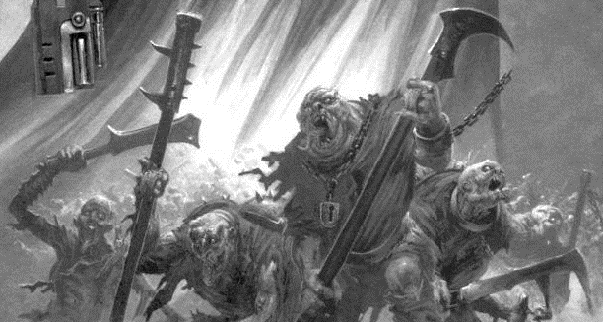
Chaos Mutants
The Chaos gods are merciless, and they give their gifts to the choice few who appease them. Much more likely, they torture and mutate them, drive them mad, and leave them to live out their short lives as monstrosities. The lesser mutants of Chaos charge recklessly into battle, with little care for their own survival. They are often seen hurtling towards the enemy on stunted legs and broken limbs, tentacles and claws dripping with bloodlust.

Points | Ws | Bs | S | T | Wounds | I | A | Ld. | Sv. | Unit
3 per | 2 | 2 | 3 | 3 | 1 | 2 | 2 | 8 | 6+ | Chaos Mutant

- Unit Composition: 20+ Chaos Mutants
- Wargear: Autogun, Clubs and Knives, Scrap Armor
- Special Rules: Fearless
  - Rampage: Mutants have bloated bodies and stunted legs, which are not well suited to fast movement. However, the creatures’ rapid ferocity more than makes up for the fact. All Mutants have the Slow and Purposeful USR; however, when moving or assaulting they roll 2d6 and choose the higher result. In addition, all Mutants have a 6+ Invulnerable save to represent their altered biology and twisted frame.
- Options:
  - The Chaos Mutants may carry Autopistols…½ point/model (round total up)

Renegade Footmen Horde
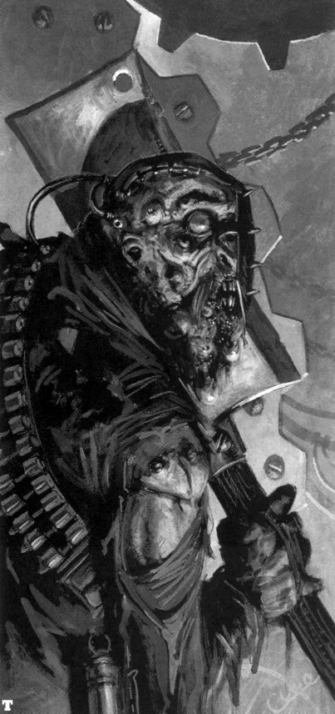
In order to fulfill their own agendas, Champions of Chaos draw lesser Chaos followers to them to form their own personal armies, which can vary tremendously in size and strength. The Traitor Guard are among the better armed and minded troops that Chaos Champions and/or Arch-Heretics have at their disposal. Like other Imperial military deserters who have turned from their Emperor and fled from Imperial justice, they will either remain mobile, travelling from system to system, or create a defensive fortress planet were they can defend themselves. Occasionally entire companies or even regiments of the Imperial Guard turn to Chaos, and take with them their vehicles and armory. These traitors, unlike other mutants, have not completely lost their military skills or sanity, forming a reasonably reliable core force amongst the slavering hordes of the Lost and Damned armies. Often these mortal guardsmen will fight alongside mutants or Daemons of the warp by summoning them by way of blasphemous rituals.

A Renegade Footmen Horde is composed of a single Champion’s Host, 1-5 Renegade Footmen squads, and 0-3 Heavy Weapon Teams. A Horde counts as only a single Troops choice, and is rolled for collectively for Reserves.
Points | Ws | Bs | S | T | Wounds | I | A | Ld. | Sv. | Unit
30 | 4 | 4 | 3 | 3 | 1 | 3 | 2 | 8 | 5+ | Champion
+6 | 3 | 3 | 3 | 3 | 1 | 3 | 2 | 7 | 5+ | Veteran
5 per | 3 | 3 | 3 | 3 | 1 | 3 | 1 | * | 5+ | Renegade
20 per | 3 | 3 | 3 | 3 | 2 | 3 | 2 | * | 5+ | Weapon Team

- Unit Composition:
  - Champion’s Host: 1x Champion, 4x Renegades
  - Renegade Footmen: 10+ Renegades
  - Heavy Weapon Squad: 3x Weapon Teams
- Wargear: Autogun, Champion has a Autopistol, Combat Knives, Flak Armor, Weapon Teams have Mortars
- Special Rules: Cursed Leadership, Slaves to Darkness (Champion’s Legion Only)
  - Gaze of Vindiction - Champions are among the greatest and most frightening warriors the Lost and the Damned can call upon, and thus their subordinates look up to them in awe and terror. His subordinates would never even consider the possibility of fleeing in the Champion’s view. All friendly units within 6 inches of the Legion must reroll failed Pinning Tests and Moral tests caused by Tank Shocking or being on the losing side of Close Combat.
- Options (Champion’s Host):
  - The Champion may carry an Icon of the Chaos Gods for his unit:
    - Khorne (+1 Attack)…15 points
    - Nurgle (+1 Toughness, except for Instant Death)…15 points
    - Slaanesh (+1 Initiative)…15 points
    - Tzeentch (+1 Invulnerable save, or 5+)…20 points
  - The Champion may replace his Bolt Pistol with:
    - Shotgun…free
    - Slugger or Bolt Gun…5 points
    - Plasma Pistol…10 points
  - The Champion may replace his Combat Knife with:
    - Mutant Weapon (+2 Strength in Close Combat)…5 points
    - Power Sword…10 points
    - Power Fist…20 points
  - The Champion may take any of the following:
    - Carapace Armor…5 points
    - Melta Bombs…5 points
    - Refractor Field…15 points
  - One Disciple may carry a Chaos Banner…15 points
  - One Disciple may carry a Dirge Caster…15 points
  - Any remaining Renegade that has not already been given one of the above upgrades may carry a:
    - Flamer or Grenade Launcher…5 points
    - Meltagun…10 points
    - Plasma Gun…15 points
  - Any Renegade may be upgraded to a Veteran…6 points
- Options (Renegade Footmen):
  - One Renegade may be upgraded to a Veteran…6 points
    - He may carry a Bolt Pistol…2 points
  - Any Renegade may replace his Autogun with:
    - Lasgun or Shotgun…free
    - Autopistol…1 point
  - One Renegade may carry a Vox Caster…5 points
  - One Renegade may carry one of the following:
    - Flamer or Grenade Launcher…5 points
    - Meltagun…10 points
    - Plasma Gun…15 points
  - Replace a pair of Renegades with a Weapon Team armed with a:
    - Heavy Stubber, or Mortar…5 points
    - Autocannon or Heavy Bolter…10 points
    - Lascannon or Missile Launcher…15 points
  - The entire squad may take Krak Grenades…10 points
- Options (Heavy Weapon Squad):
  - Replace the Team’s Mortar with a:
    - Heavy Stubber…free
    - Autocannon or Heavy Bolter…10 points
    - Lascannon or Missile Launcher…15 points

Sappers
Whenever there is an Imperial Invasion of a Chaos world, invariably the defenders lie in a myriad of fortifications, ranging from hastily constructed trenches and barricades, to fully made fortresses and keeps. Thus, Imperial Guard Legions and Adeptus Astartes invaders must trudge and crawl through miles of mines and barbed wires to reach their objective. Someone had to toil for months to create the heavy defenses and walls, and that job is left to the Sappers. Any Lost and the Damned army is accompanied by Chaos-turned workers and engineers, who still hold onto their pre-insanity skills and know-how. These Sappers are tasked with the defenses of any Chaos-held planet. However, once battle is met, they too are forced to the front-lines. Equipped with heavier armor and specialized equipment, Sapper units turn their destructive skill on the invaders.

Points | Ws | Bs | S | T | Wounds | I | A | Ld. | Sv. | Unit
+6 | 3 | 3 | 3 | 3 | 1 | 3 | 2 | 7 | 4+ | Veteran
12 per | 3 | 3 | 3 | 3 | 1 | 3 | 1 | * | 4+ | Sapper

- Unit Composition: 5-10x Sappers
- Wargear: Carapace Armor, Combat Knives, Frag and Krak grenades, Shotguns
- Special Rules: Cursed Leadership
  - Expert Demolitions: Sappers are grenadiers without peer, their extensive training with industrial explosives granting them experience in their best applications. Whenever a unit of Sappers assaults an enemy unit, their charge is always lead by a hail of both Military and Improvised grenades, thrown into the thick of the enemy. Units charged by Sappers immediately take d6 Strength 4, AP 6 hits to represent the expertly thrown explosives. These hits are allocated before normal Close Combat.
  - Trenchers: Sapper units are quite adept at hiding in ruins and trenches, and can always find the best cover possible there. It was they who created them, after all. Sappers gain the Stealth USR when in Ruins, Bunkers, behind Barricades, in Trenches, or similar “industrial” terrain.
- Options:
  - One Sapper may be upgrades to a Veteran…6 points
    - The Veteran may carry a Grenade Launcher…10 points
  - The Veteran may carry Melta Bombs…5 points
  - Replace a pair of Sappers with a Weapon Team armed with a:
    - Heavy Flamer or Mortar…5 points
    - Missile Launcher…15 points
  - The entire squad may carry Autopistols…3 points/model

Dedicated Transports

Cobbled Hauler
The Lost and the Damned are scrap workers and scavengers without peer, nearly as talented as the notorious Orks that plague the Galaxy. Often, massive constructions fashioned from the remains of Imperial transports and piles of scrap metal. These monstrous machines are used to ferry large quantities of Renegades, Mutants, and Ogryn into the battle. Their size and shape varies widely, some resembling Imperial Gorgon transports, others closer to civilian vehicles outfitted with hastily crafted weapons and armor.

Points | Bs | Front Armor | Side Armor | Rear Armor | Unit
80 per | 3 | 13 | 11 | 10 | Cobbled Hauler

- Unit Composition: 1x Cobbled Hauler
- Wargear: Heavy Stubber, Smoke Launchers
- Special Rules: Vehicle: Fast, Tank, Transport capacity: 20 models
- Options:
  - The Cobbled Hauler may take up to three additional Heavy Stubbers…5 points each
    - Any Heavy Stubber may be replaced with a Mortar…free
  - The Cobbled Hauler may take any of the following:
    - Search Lights…2 points
    - Dozer Blade…5 points
    - Extra Armor…15 points
    - Daemonic Possession…20 points

Stolen APC
The Traitor Space Marine Legions who escaped into the Eye of Terror at the end of the Horus Heresy brought their many Rhino tanks with them. The Rhinos used by the Forces of Chaos are a mixture of all marks and patterns, and have all been modified and outfitted in uncountable ways, all of which are deemed blasphemous by the Adeptus Mechanicus. The vast majority of Rhinos in service to the Forces of Chaos are of the newer models, as these are both captured from Loyalist Space Marine Chapters or are ceded to Chaos when a Chapter has turned Renegade. There are many Rhinos being produced by their hundreds everyday within the Eye of Terror on Chaos War Worlds. Many smaller Chaos warbands, particularly the Lost and the Damned, will scour battlefields in order to find and recover battlefield wreckage, and thus are able to add to the number of Rhinos and other vehicles they have at their service.

Points | Bs | Front Armor | Side Armor | Rear Armor | Unit
40 per | 3 | 11 | 10 | 10 | Stolen APC

- Unit Composition: 1x Stolen APC
- Wargear: Heavy Stubber, Smoke Launchers
- Special Rules: Vehicle: Tank, Transport capacity: 10 models
  - Repair: Stolen APC’s are often manned by traitor members of the Mechanicus, and crewed by ancient servitors. These trained crews are easily able to repair damage to the vehicle, even in the heat of battle. At the beginning of the shooting phase, a Stolen APC can repair the Immobilized damage result on a d6 roll of 6.
- Options:
  - The Stolen APC may replace its Heavy Stubber with a Havoc Launcher…10 points
  - The Stolen APC may take any of the following:
    - Search Lights…2 points
    - Dozer Blade…5 points
    - Extra Armor…15 points
    - Daemonic Possession…20 points

Fast-Attack

Mongrel Pack
The Lost and the Damned make full use of every advantage they can get their plague-ridden hands on, in their never-ending war with the Imperium of Man. One of these numerous advantages is the breeding of large masses of mangy and feral hounds to be used as shock troopers and terror-weapons. Whipped forward by a brutal Slaver, the starved beasts are launched towards the defensive positions of the enemy, to root out infantry and gunners.

Points | Ws | Bs | S | T | Wounds | I | A | Ld. | Sv. | Unit
5 per | 3 | 0 | 4 | 3 | 1 | 4 | 1 | 6 | - | Mongrel
10 per | 3 | 3 | 3 | 3 | 1 | 3 | 2 | 8 | 4+ | Slaver

- Unit Composition: 5-20x Mongrels, 1x Slaver
- Wargear:
  - Mongrel: Savagery (Close Combat Weapon and Assault Grenades)
  - Slaver: Autopistol, Carapace Armor, Whip
- Special Rules: Beasts, Move Through Cover

Ghast Pack
Perhaps the most dreadful and terrible creation of the Chaos Gods is the Ghast. Forged together from the fused flesh of numerous rotting corpses, these shambling horrors move with speed and strength seemingly impossible from their abundant legs and arms. Skilled Sorcerers and Priests will call upon the dark gods in foul and lengthy rituals to create these monstrosities, and send them out to hunt for prey across the waste lands of a war-torn world. Worst yet, the creatures will lurk in piles of debris and corpses, consuming what flesh they can find in numberless, gapping mouths. In these putrid hiding places they burst forth, like the newly risen dead, and storm towards the nearest source of fresh meat they can find.

Points | Ws | Bs | S | T | Wounds | I | A | Ld. | Sv. | Unit
24 per | 3 | 0 | 3 | 5 | 2 | 2 | 4 | 10 | 6+ | Ghast

- Unit Composition: 3-10x Ghasts
- Wargear: Claws and Spines, Scrap Armor
- Special Rules: Fearless, Move Through Cover
  - Grave Burst: Ghasts are left hidden inside piles of corpses and rubble, their grotesque and mutilated bodies effectively disguising them as dead bodies. The horrid creatures are “trained” to burst from their hiding places when prey draws near, and launch shambling assaults against anything in reach. All Ghast units must begin the game in reserve. When deployed, the Ghasts are placed on the board, as if they had just infiltrated. However, they must be placed in a piece of terrain. The Ghasts must be at least one inch away from all enemy units. In addition, Ghasts may Assault, but cannot move the turn they enter play. If the unit does Assault, it must take a Dangerous Terrain test.
  - Festering Wounds: The rotting body of a Ghast is home to thousands of bacteria, diseases, and acids dripping from their swollen frames. All Ghasts have the Poisoned USR in Close Combat, and therefore always wound on a 4+.
- Options:
  - The Ghasts may be equipped with “Explosives Charges”…6 points per model
    - When the last Ghast in the pack loses its final wound, center the 5” Diameter blast template over the model. This explosion is treated exactly as a Demolition Charge, but it does not scatter. All models under the template are hit.

Hell Hound
See Codex: Imperial Guard for Hell Hound flame tanks. However, only a single Hell Hound may be taken, they cannot be taken in squadrons. Otherwise, the rules and options remain the same.

Heavy Support

Daemon Prince
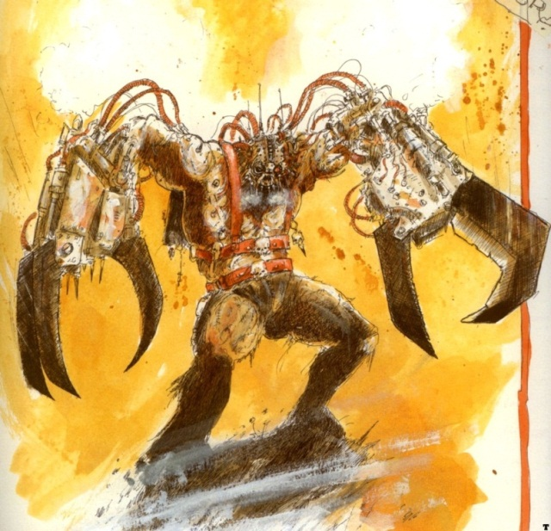
A Daemon Prince is a human Champion of Chaos who has been elevated to daemonhood as a reward for his actions on the behalf of one of the major Chaos Gods, or by the will of Chaos Undivided. Daemon Princes have chosen to trade their humanity for the god-like power and immortality provided by becoming a creature of the Warp, and a living extension of the force of Chaos. This is the ultimate goal of the most powerful followers of Chaos, as it gives them immortality and power beyond the reckoning of mortals. Daemon Princes combine the brute strength of daemons with the skill and tactical knowledge of the Astartes. However, if the Champion fails in the eyes of their God, their lives and ambitions end as they are cast aside and instead descend into the mutant state of a Chaos Spawn.

Points | Ws | Bs | S | T | Wounds | I | A | Ld. | Sv. | Unit
110 per | 7 | 5 | 6 | 5 | 4 | 5 | 4 | 10 | 3+ | Daemon Prince

- Unit Composition: 1x Daemons Prince
- Wargear: A single bloody sword
- Special Rules: 5+ Invulnerable save, Eternal Warrior, Fearless, Monstrous Creature
- Options:
  - The Daemon Prince may carry a Chaos Icon:
    - Khorne (+1 Attack)...+25 points
    - Nurgle (+1 Toughness, except for Instant Death)...+35 points
    - Slaanesh (+1 Initiative)...+25 points
    - Tzeentch (+1 to Invulnerable save, or 5+)...+50 points
  - A Demon Prince may take up to two Psychic Power listed in Codex: Chaos Space Marines (Point costs are listed in the book). Taking any Psychic Powers makes the Daemon Prince a Psyker.

Chaos Defiler
A Defiler is a potent Daemon Engine mounted on 6 piston-driven limbs that serves in the armies of the Chaos Space Marines. The Defilers were created after the Horus Heresy on the orders of Abaddon the Despoiler to supplement the forces of the Traitor Legions, whose remaining Chaos Dreadnoughts were no longer the reliable heavy support units they had once been, before their transformation into the insane cybernetic servants of the Ruinous Powers. Unlike the main battle tanks of the Imperial Guard and the Loyalist Space Marines, the Defiler is not operated by a human crew, but by the Warp energy of a bound daemon of Chaos. Using complex sorcerous rites, the adepts of the so-called Dark Mechanicus work with Chaos Space Marine Sorcerers to draw forth the essence of a daemon from the Warp and trap it within the rune bound mechanical body of a Defiler. Enraged by its imprisonment, the daemon needs to be sedated by spells of appeasement which are only lifted when battle begins. With its full anger unleashed, the daemon drives the Defiler forward on it mechanical legs, spewing death from its implanted weaponry. It rejoices in battle, ripping apart the enemy with its great claws while emitting terrible roars of rage and delirious battle-joy from its vox-grilles. Unconcerned for its survival since it seeks release back into the Immaterium, the Defiler's bound daemon ignores the blasts of missiles and detonations of artillery and Bolter shells against its armored body, advancing through the heaviest weapons fire without hesitation.
Points | Ws | Bs | S | Front Armor | Side Armor | Rear Armor | I | A | Unit
150 | 3 | 3 | 6 | 12 | 12 | 10 | 3 | 3 | Chaos Defiler

- Unit Composition: 1x Chaos Defiler
- Wargear: Battle Cannon, Heavy Flamer, Reaper Autocannon, Searchlight, Smoke Launchers, Two Dreadnought Close Combat Weapons
- Special Rules: Daemonic Possession, Fleet, Vehicle: Walker
- Options:
  - The Defiler ma replace its Heavy Flamer with:
    - Dreadnought Close Combat weapon (+1 Attack)…free
    - Havoc Launcher…5 points
  - The Defiler ma replace its Reaper Autocannon with:
    - Dreadnought Close Combat weapon (+1 Attack)…free
    - Twin–Linked Heavy Bolter…free
    - Twin-Liked Lascannon…20 points

“Lords of the Land” Defenses
See Codex: Renegades and Heretics for rules regarding Artillery Strikes, Minefields, Sentry Guns, and Turrets. Any number of these can be taken as a single Heavy Support choice for a Lost and the Damned army. However, any army may only select a single Artillery Strike per 1000 points.

Liberated Tank
When PDF units or other stationed soldiers turn to Chaos, the inevitably bring their armaments and vehicles with them into battle. Thus, Chaos owned Leman Russ, Predators, and Land Raider tanks are a common site in a battle with the Lost and the Damned. Furthermore, these already large battle vehicles are up-armored and have even larger cannons welded to their frames than before, lending to a variable display of armor and weaponry.

Points | Bs | Front Armor | Side Armor | Rear Armor | Unit
160 per | 3 | 14 | 13 | 11 | Liberated Tank

- Unit Composition: 1x Liberated Tank
- Wargear: Battle Cannon, Heavy Bolter, Smoke Launchers, Search Lights
- Special Rules: Lumbering Behemoth (See Codex: Imperial Guard), Vehicle: Tank
- Options:
  - The Tank may replace its Battle Cannon with a Twin-Linked Heavy Mortar…free
  - The Tank may replace its Heavy Bolter with:
    - Heavy Flamer…free
    - Lascannon…15 points
  - The Tank may take a pair of Sponsons armed with:
    - Heavy Bolters or Heavy Flamers…20 points
    - Plasma Cannons…40 points
  - The Tank may take any of the following:
    - Dozer-Blade…10 points
    - Pintle mounted Heavy Stubber…10 points
    - Camo Netting…15 points
    - Extra Armor…15 points

Summoned Daemons

Lesser Daemons
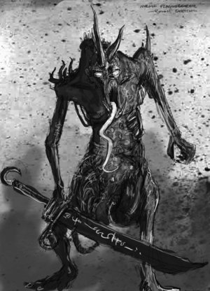
The Lesser Daemons of Chaos are the most numerous entities of the Warp. The legions and servants of the Dark Gods are countless and diverse. These are the warriors, the guard beasts, the messengers and the tallymen of Chaos – the teeming masses of daemonkind that exist solely to serve their creator's dreams and whims. The Lesser Daemons and Daemonic Beasts are the true armies of Chaos, who wage a never-ending war with the hordes of the other Gods of the universe for power and dominance. Lesser Daemons are slaves to the will of their master, little more than extensions of the mind and will of the Chaos God they serve, created and discarded without effort or thought. Though nothing more than lowly minions in the Realm of Chaos, such daemons are nevertheless potent entities in the material universe. Their otherworldly nature grants them speed, strength and resilience beyond that of men. For those with the knowledge and will, it is possible to tear through the barriers between worlds and allow the daemons to spill forth. Once they are through, the daemon packs fall upon the foe with relentless ferocity, for their time in the mortal world is limited. They crave every moment and experience to be had in the mortal realm before their power fades and they are banished back to the Realm of Chaos within the seething, swirling eddies of the Warp.

Points | Ws | Bs | S | T | Wounds | I | A | Ld. | Sv. | Unit
13 per | 4 | 0 | 4 | 4 | 1 | 4 | 2 | 10 | - | Lesser Daemon

- Unit Composition: 5-20x Lesser Daemons
- Wargear: A single bloody sword
- Special Rules: 5+ Invulnerable save, Fearless, Summoned Daemons

0-1 Greater Daemons
Amongst the teeming daemonic hordes of Chaos, a Greater Daemon is the most powerful. They are incarnations of their Chaos God, living embodiments of everything Chaos represents. They are the guardians of their God's realm and the executors of his will. Often the Greater Daemons lead incursions into the mortal world, and act as the heralds of the Ruinous Powers of Chaos to Champions of Chaos and Sorcerers. Yet, they still have their own ambitions and plans, each contributing a part to the greater consciousness that is the Ruinous Powers. In realspace, Greater Daemons manifest as huge, terrifying creatures capable of slaying scores of warriors and destroying even main battle tanks. They have strange, sorcerous powers drawn from the psychic energy of the Warp and are virtually impervious to mortal weapons. Summoning such a creature demands a high price, for it takes a tremendous amount of psychic energy for a Greater Daemon to achieve corporeality in the material universe. The price is always a sacrifice, the death or possession of a living being that acts as a gateway from the Immaterium into the material realm. The rampant energy of the daemon passing through into the material universe inevitably destroys this host. As such, the sacrifice is not usually the one performing the summoning.

Points | Ws | Bs | S | T | Wounds | I | A | Ld. | Sv. | Unit
100 per | 8 | 0 | 6 | 6 | 4 | 4 | 5 | 10 | 3+ | Greater Daemon

- Unit Composition: 1x Greater Daemon
- Wargear: A single bloody Sword, Plated Armor
- Special Rules: 4+ Invulnerable save, Fearless, Monstrous Creature, Summoned Daemons

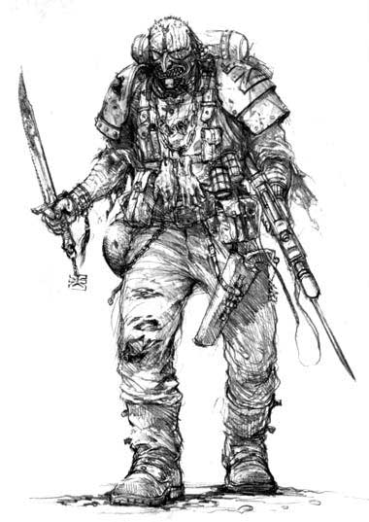
The Blood Pact is a warrior Chaos Cult dedicated to the service of the Chaos God Khorne, which is currently engaged in trying to maintain the grip of the Forces of Chaos on the Sabbat Worlds. They are sworn to the service of the Archon Urlock Gaur, the leading Chaotic warlord of the Sabbat Worlds Sector, and are named the Blood Pact after the Chaotic ritual in which they are sworn into the Archon's service. The ritual requires the Blood Pact initiate to slice the palms of his hands on the jagged edges of the Archon's Power Armour. In rare cases, such as for snipers in which the hands are essential, another part of the body may be cut to seal the pact. The Blood Pact is highly unusual among Khornate Chaos Cults in that it fights as a highly-disciplined army rather than the disorganized warbands of berserkers that normally characterize Khornate devotees. Comprised of both highly-trained human troops and xenos mercenaries, the forces of the Blood Pact were instrumental in Chaos' victory in overrunning the Sabbat Worlds and are equally important in defending the Forces of Chaos' gains from the ongoing Imperial Sabbat Worlds Crusade. The Blood Pact is easily the equal of standard Imperial Guard Regiments in its discipline and effectiveness.
Named Characters

The Grimwyrm
The Grimwyrm is an ancient being, having walked the path of Chaos for nearly a millennia. It is rumored that he was once a member of the Adeptus Custodes, but whether this is the truth or not is irrelevant. What is known of the ancient being is that he has been gifted with power at the hands of Tzeentch, the Lord of Change. Tzeentch has made him one of his Harbingers, tasked to bring about mutation of all kinds, in the name of the Lord Tzeentch. The Grimwyrm has leaped to the task, and leads a massive force of Chaos Mutants and Renegade Guardsmen alongside the Lost and the Damned.

While he is a great creator of mutation, the Grimwyrm is only a human being. He is no master swordsman, or great warrior. His power lies in the creation of his servants. Surrounded by hordes of Renegades, mutants, and monstrosities, the Grimwyrm’s armies, and his allies, grow in strength every day.

Points | Ws | Bs | S | T | Wounds | I | A | Ld. | Sv. | Unit
90 | 4 | 4 | 3 | 4 | 2 | 3 | 3 | 9 | 5+ | The Grimwyrm
Na. | 3 | 3 | 3 | 4 | 1 | 2 | 2 | 8 | 5+ | Grimwyrm’s Finest

- Unit Composition: See “Unique Champion’s Legion”
- Wargear:
  - The Grimwyrm: Flak Armor, Frag Grenades, Grenade Launcher, Power Sword
  - Grimwyrm’s Finest: Autogun, Combat Knives, Flak Armor, Frag Grenades
- Special Rules: Slaves to Darkness, Stubborn
  - The Lord Transmuter: The Grimwyrm is a harbinger of Tzeentch, and he is one of the few beings the Lord of Change has given his gift of mutation to. Such is the Grimwyrm’s gift that he can even raise lost Chaos Mutants from the dead, tearing and twisting their already tortured forms back to their feet, to return to the fight. At the beginning of every Lost and the Damned turn, replace 2d6 Chaos Mutant models to every unit on the board. This cannot bring the unit past its original model count, nor will it replace lost Independent Characters that died while in the unit.
  - Tortured Anatomy: The Grimwyrm is heavily mutated, and his flesh has been replaced with scarred and mutilated hide, his limbs ending with massive talons. What is not already corrupted has been replaced with ancient augmetics, built before even the events of the Horus Heresy. To represent his mutations and attachments, The Grimwyrm has a 4+ Invulnerable save.
  - Unique Champion’s Legion: The Grimwyrm is taken in a Lost and the Damned army as a Champion Legion, replacing the standard version in a Renegade Footman Horde. This Champion’s Legion is composed of the Grimwyrm, and four of the Grimwyrm’s Finest, elite mutants created to be faster and tougher than standard Chaos Mutants. They can take any upgrades available to a standard renegade in a Champion’s Legion; however they may not be upgraded to Veterans. In addition, in any army including the Grimwyrm, there must also be at least one unit of Chaos Mutants.

