ANIMOSITY
In The Discordia system

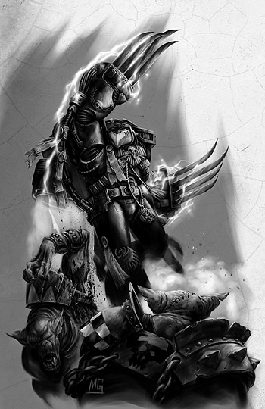
December 15th and 16th 2012
A warhammer 40,000 campaign weekend

The Discordia system
The Emperor Dias shook violently. The Inquisition ship had dropped from the warp and into the waiting sights of enemy guns. There was no doubt this was a trap, the waypoint had been specifically selected because Discordia was a dead system, decimated over ten thousand years before Dondian’s vessel broke from the treacherous warp seas.
Dondian was thrown from his feet, the deck ringing as his knees smacked the metal floor. “Secure the artefact on the lander.” He ordered via his personal comm. “We’ll have to evacuate on-board the Aquila and trust in the Emperor we can avoid the heretic guns.” Dondian clambered to his feet and continued to the hangar. His Aquila was not warp capable; it would only see them to safety within the system. They would have to flee the renegade ambush and hope the astropathic choir had managed to send their message to the Lord Inquisitor.
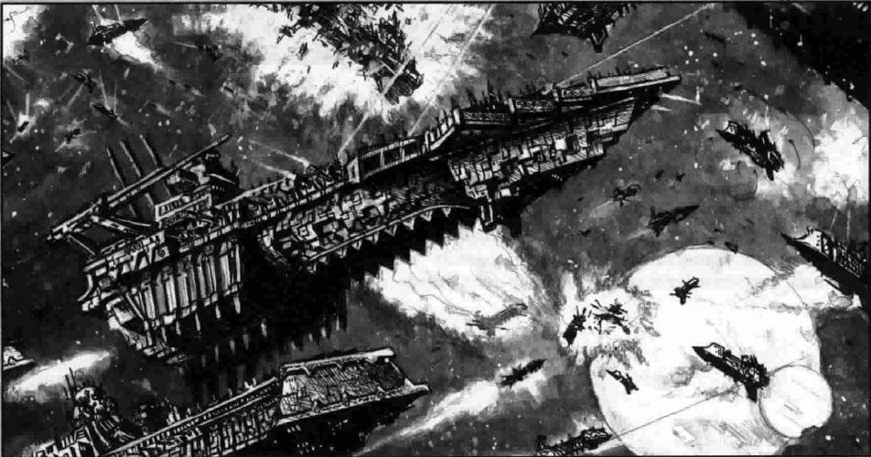
The Aquila bucked as it broke into the atmosphere of Discordia III. Dondian could not keep his eyes from the cockpit door. Through the door, secured as safely as time would allow when the renegade guns began to systematically reduce the Emperor Dias to space scrap, was the Lord Inquisitors prized artefact.
The Aquila barrelled violently. “What the frak?” The pilot wrestled with the controls as the Aquila spun through the atmosphere of Discordia III. “We’ve been hit by something, debris?” Dondian checked the on-board auspex. Emperor Dias was gone. They had been hit by fragments of the shattered ship. “What’s happening up there Interrogator?” The pilot yelled as he fought the spiralling lander.
Interrogator Dondian did not answer. He took one last glance at the sealed door and hoped the Inquisitor had received the distress call. He knew the gravitational forces acting upon the lander would spare him from the horror of impact. He would pass out before they hit the ground. The landscape below was white, bright and spinning.
Discordia III
The creature stirred. The earth trembled, and trembled again. There was warmth to the atmosphere. The long hibernation was over. With a wrench the creature broke free of the constricting ice. The creature could feel the brood mind around him waking. There was a scent on the air, bio-mass. As the creature tore its hulking form free of the tight ice and stretched its long limbs the sky above it was torn. Flaming metal super structure rained upon the planetoids surface. Impact after impact superheated the polar regions of Dicordia III and the Hive Tyrant felt the frozen consciousness of his swarm stir. The creature took a tentative step upon the ice. It moved forward tasting the air. The Tyrant reached out, not with his frost covered arms but his cold penetrating mind. He could sense the familiar warmth of the hive mind. It was distant but he could reach it. He began to silently call out to the spawn ships…
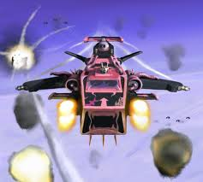
The Sublime child
The Emperors Children delighted in the clinical strike. The Inquisition cruiser had been reduced to nothing more than twisted wreckage. Flares of superheated gases erupted from the cracked spine of the ship and the last of the oxygen burnt in its cataclysmic death throes. The boarding assault would be unnecessary. The artefact had been evacuated by shuttle before the Sublime Child’s torpedoes had detonated deep within the bowls of the Emperor Dias. Landing craft had been prepared; the legion would find the Aquila and the artefact before Abaddon’s black clad traitors and renegades were in system.
Claxons screamed, the Sublime Child was under attack. The ship wide comm system croaked. “This is Commander Narcissus. Prepare to repel boarders.” Power armoured trans-humans in gaudy pinks and blacks stomped through the twisted corridors of the Sublime Child. Bolter mechanisms were raked and released, weapons readied. Red lenses flared in anticipation as the traitor marines prepared to take the lives of the foolish invaders.
Blue corposant scattered across the corridors. Web-way portals twisted into existence across the chaos craft. Lithe, nimble bodied aliens stepped through from an unknown source. The Eldar had breached the Sublime Child.
Task Force Pengadilan
Inquisitor Jasks Pengadilan wrapped his fingers against his ancient desk. The dark tidings from the Discordia system had left him pensive. He had been assembling his task force since Dondian had set out to retrieve the artefact. Maybe if he had gone… …but no, Dondian did not have the experience or the authority to assemble the fleet in his stead. The fleet was due to translate into the warp in moments. The message from Discordia was disturbing but Pengadilan prayed to the Emperor that he would receive another prior to warp transit. Pengadilan stared intently at the power armour arrayed upon the wall. Conflict was necessary to preserve the Imperium, Jasks had no illusions to the contrary, but the fleet alone would not be enough to protect the Imperium should the artefact fall into the hands of aliens or renegades. “Warp translation in t-minus 15.” Pengadilan shook his head in reflection of the doom that awaited the fleet in Discordia. “Inquisitor Pengadilan.” The comm called out. “We have received acknowledgement my Lord Inquisitor, translation delayed, awaiting your orders.”
Pengadilan broke into a run as he made for the bridge. He burst through the door, Captain Hornchurch turned, a grin as bright as the astronomican beaming across his face. “The message my Lord, they’re en-route, the Legions Astartes.”
“Which chapter has answered our call Hornchurch?” The Inquisitor asked
Hornchurch flustered as he retrieved the message transcript from a servitor. “I’d say my Lord, all of them.”

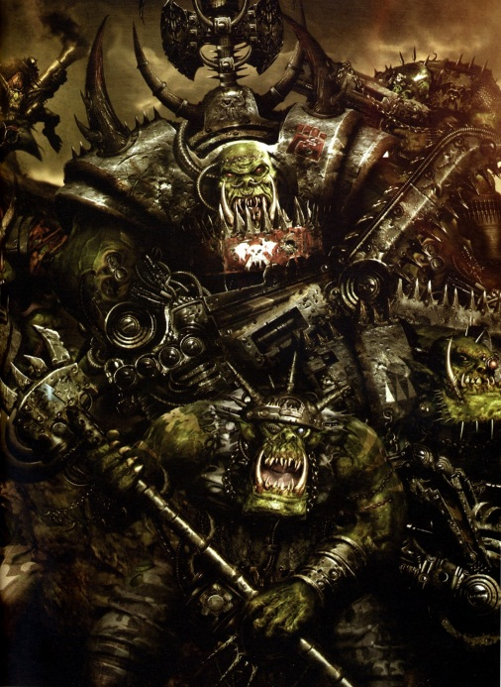
2nd Moon of Discordia III
Spinebusta pulled his finger from his nose with a wet pop! He was by no means the brightest of Orks, nor the strongest, but Spinebusta new when it was time to stop picking his nose. The black skies above were different. The planet of Discordia III around which Spinebusta’s home orbited, flickered with light. The Orks thought Discordia III was the eye of Gork. The glaring red eye of Mork sat beside it. Spinebusta had never taken much interested in the eyes of the gods. They watched him, he knew that as all Orks knew, but mainly they watched him picking his nose, as it was Spinebusta's favourite pass time. Now Spinebusta stared back. The eyes of the gods had drawn nearer, as if scrutinising their Ork sons sat idly. It was the flashing lights that had drawn Spinebusta’s notice. Flares of fire and huge rending explosions silently surrounded the eyes of the twin Ork gods. Spinebusta wiped the snot from his nose across his jacket sleeve and with his relatively clean fingers he grasped his shoota. Spinebusta may not have been the brightest of Orks, nor the strongest, but he was clever enough to realise when his angry gods were sending the Orks a message. Too long they had sat idle, only fighting each other, which was fun admittedly, but not as good a fighting everybody else. Spinebusta stood up and raised his shoota in the air. A few lazy boyz looked up from their scratching. A few clever grots ran for cover. A few hundred Orks heard the roar. Soon it would be heard by lots more. Spinebusta, staring into the eyes of the Ork gods as he did so, let out a guttural bellow. “WAAAAAAGH!”

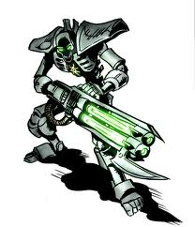
Forest moon of rendor
Trazyn the Infinite gazed into the swirling green orb. The frail humanoids had already caught his baleful eye, the arrival of the trans-humans had peaked that interest. His living metal fingers tapped out a rhythm long forgotten by the ancient Necron’s Praetorians, who stood in silent observance of Trazyn’s scheming. Trazyn saw the converging lines of fate coming together as inevitably as the artefacts he hoped to add to his burgeoning collection. If his cold metal shell had the ability to narrow its gaze in contemplation it would have done so, instead the laser green glow of his dead eyes narrowed in sharp focus. Trazyn turned his attention to the Praetorians. Without needing to vocalise any instructions, the Praetorian turned and made their way out of his private chambers and left for the Forest Moon. They would arrive within moments, Trazyn knew, and they would begin to wake the soulless minions he would command to further his own ends in the Discordia system. Trazyn would reap the bloody harvest, keeping the most succulent morsels for his own delectation. He almost laughed at how easily he would manipulate the trans-humans, they would walk willingly into his collection. The Great Bear of the Vulka-Fenrika would be the first of many.

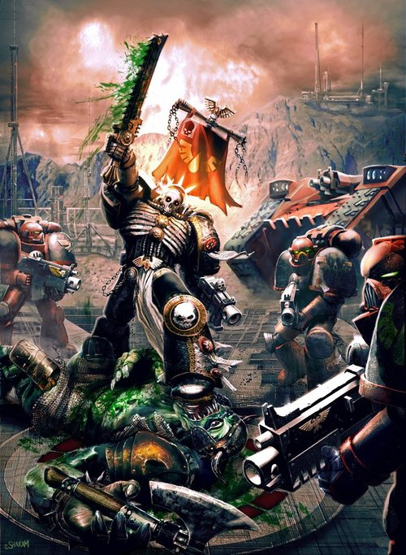
Gaming schedule
DAY one Day two
game one – 40-40 kill team GAME FIVE - APOCALYPSE
- 400 pts - 3000 to 4000 pts
- 40” x 40” Board set up - Apocalypse Table
- 40 Minute time limit - Start – End Game
- Animosity Kill Team/Zone Mortalis rules - 6th edition/Apocalypse/Campaign Rules
- Animosity Kill Team force org - Campaign Force Org
Game two – Beachhead
- 1800 pts
- Standard table
- 2 Hour time limit
- 6th edition game rules (defender/attacker tba)
- 6th edition/campaign force org
Game three – standard game
- 1500 pts
- Standard table
- 2 Hour time limit
- 6th edition game rules
- 6th edition force org
Game four – doubles game
- 1500 pts (per player)
- Standard table
- End game
- 6th edition game rule
- 6th edition force org

Ancillary rules
Game one – The 40–40 Kill Team game represents the first contact between opposing forces and therefore is designed to be played as a fast paced skirmish. A time limit is in place for play only. Players must be deployed when the countdown begins. Infiltrators/scout moves etc, are carried out as normal. Animosity Kill Team force organisation consists of NO – HQ, Vehicles or Armour Saves which better Power Armour (2+ saves basically). Walkers and Monstrous Creatures may be used. Animosity Kill Team does not split units into individuals. Any actions involving tunnels, space craft etc, will use a variation of the zone mortalis rule set created by Forgeworld. These rules are available at the end of the campaign pack.
Game two –Beachhead uses the 6th edition rules for Warhammer 40,000. A time limit is in place for play only. Each player will require two army lists for this mission. Each player has a 1500 point Base List which uses the 6th edition force organisation chart, without the fortification slot. Each player will require two sets of 300 further points. 300 points for their attacking force and 300 points for their defending force. Attacking forces must not contain fortifications. Defending forces must contain at least one bastion but can allocate up to 300 points towards fortifications if they wish., the remainder of their points can be spent freely. Attacking and defending will be determined by the narrative so please prep lists for both. Players must be deployed when the countdown begins. Infiltrators/scout moves etc, are carried out as normal.
Game three – Standard 6th edition rules apply for both force organisation and mission selection. This is the first opportunity for players to employ their Bonus Points. The Bonus Points rules can be seen on the Victory point’s page. Any use of bonuses must be arranged prior to deployment. The time limit is in place for play only. Players must be deployed when the countdown begins. Infiltrators/scout moves etc, are carried out as normal.
Game four – Standard 6th edition rules apply for both force organisation and mission selection. This is the second opportunity for players to employ their Victory Point Bonus. The Victory Points Bonus rules can be seen on the victory point’s page. Any use of bonuses must be arranged prior to deployment. There is no set time limit for the doubles game as they often take longer to complete but players should look to complete gaming by 20:00 (8pm to the non-military types). Players play using their 1500 pts singles force. Should doubles players feature repetition of unique characters this will be overlooked for the purposes of the doubles game.
Game five – Standard 6th edition/Apocalypse rules apply. Players must include their 1500 Base Force within their total and a minimum of one complete force organisation chart must be completed prior to using Apocalypse force org. Players are required to field 4000 points however, with prior notice a smaller list can be accommodated. Players wishing to field larger forces can also do so if they wish. Players wishing to field a larger force must use a 4000 point base list as required. Over and above 4000 points must be added as a second list and will be taken into consideration as gaming needs allow (other players bringing larger forces etc).
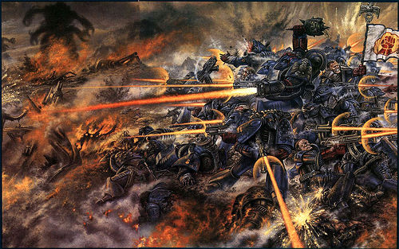
Victory + bonus points
During the Campaign weekend Victory will be determined using the victory conditions detailed in the rules set used for each game. Bonus points will be granted to task forces upon completion of secret missions and for each victory by a task force participant.
Bonus points can also be used to gain advantages in subsequent missions by hiring mercenaries, requesting reinforcements or summoning daemonic allies from the warp.
Mercs will be available to each task force, to be detailed to a member of the task force as the task force commander sees necessary.
However, hiring mercs will cost you. Any bonus points used to hire or call reinforcements will be lost from the task force total…
Each victory by a task force member will gain 3 points for the task force. Players receive 1 point for a draw and 0 points for a loss. Should a player complete their secret missions they will receive 3 bonus points for their task force. Secret missions will be drawn randomly by the task force commander prior to deployment and the chosen mission will be detailed to each of his task force comrades. The exception to this will be the Tyranid players, who need only consume all bio-mass from his opponents force to achieve their bonus victory.

Campaign victory
Campaign victory will be determined by the Task Force that accumulates the most Victory points. Bonus points will be used to determine a winner should there be a stalemate when the campaign ends. The Apocalypse battle will count towards victory points and there will be bonus missions detailed to each task force whilst the Apocalypse battle is in play.

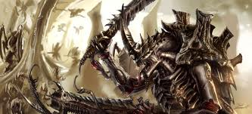

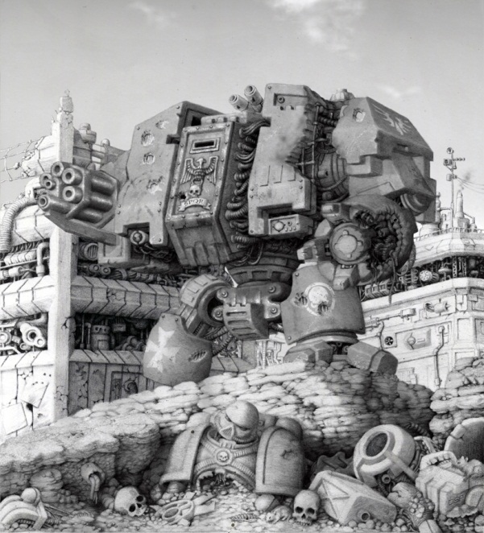
Mercenaries
Each Task Force will be able to hire mercenaries, call reinforcements, summon warp spawned allies or scream out to the hive mind for assistance. Bonus points will be exchanged for the assistance of your faction reinforcement. The use of these forces will be in addition to the forces allocated prior to deployment. Each hired unit can only enter the game via reserve or in whatever manner is detailed in the units data sheet, an example would be a drop pod dreadnought. It will enter via deep strike or can be included in the Space Marine players initial drop pod assault should he wish.
The mercenaries and reinforcements available can only be requested should they feasibly be available to your chosen Task Force. An Eversor Assassin for example would be available for any faction that is human in origin, even the Heretics or Renegades… what’s to say assassins don’t switch sides? The Eversor would not however, be available to Orks, Necrons or any other xenos race.
There will be a number of bonus units available to each faction, they will vary in size and original points cost which will be represented by the bonus points required to gain their services.

DAEMON PRIMARCHS
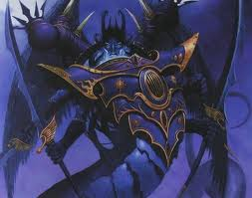
During the 41st Millennium The Emperors heretic sons can be found deep within the Eye of Terror, rarely if ever venturing back into the realm of the Imperium. Pengadilan’s artefact is powerful, beyond even the Inquisitors imaginings. The lost Primarchs are not so naïve and are fully aware of the potential held within. The dark secrets of the artefact could be bent to the will of the Daemon Primarch who could secure it.
If you are lucky enough to have been blessed by the gods of Chaos, then it may be possible to field a Daemon Primarch. Available for the Apocalypse game only, rules for the Daemon Primarchs, Angron, Mortarion, Fulgrim and Magnus can be found on the Tempus Fugitives website. Simply download the Age of the Emperor Expansion pack and go to page 124. There you will find the rules for the Daemon Lords. They will be available for use at 350 points each, should you be reckless enough to stir the Daemon Primarchs from the Eye they will automatically become your Apocalypse HQ.

Campaign competitions

Bitz box conversion competition: Our Campaign Sponsor, Bitz Box, has organised a prize for the best Converted miniature featured in the campaign. The rules are simple. Enter a single miniature on a 25mm or 40mm base which has been converted using multiple parts from multiple kits. Dynamic bases using bitz should also be taken into consideration for the voting. The winner will be decided by ballot vote by the campaign players. Painting to a high standard is not necessarily the way to victory. I urge all participants to remember that it is a conversion competition. For the painters we have…

Animosity painting competition: To enter the painting competition simply enter a painted and based single unit. The unit can be anything, HQ, Troop, Tank… as long as it is not a Super Heavy of any kind. The single unit painting competition will also be voted for by campaign players using a ballot vote.

Maelstrom man of the match: The Maelstrom Man of the Match Award is for heroes. During the Campaign weekend it is likely that many headstrong heroes will rush in where angels fear to tread… and they’ll get munched! However, some heroes will be blessed by the dice gods and survive despite these odds. The Maelstrom Man of the Match Award will go to the player who succeeds where grim failure should have been the only outcome, in short if you find yourself facing an all or nothing, desperate last stand, roll the dice and take your chances! If you find yourself wide eyed in disbelief make a note of the event, at the end of the game go to the Merc desk with details of your tremendous tail of daring do. Bring your opponent; we aren’t going to believe idle battlefield gossip!

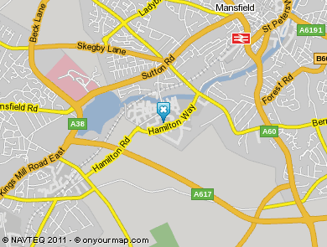
MAELSTROM GAMES
Matlock Mill, Hamilton Way, Mansfield, Nottinghamshire NG18 5BU
Tel: 01623 238919
Maelstrom Games is a great gaming venue. They have a bar and will be providing a buffet at lunch time on both the Saturday and the Sunday. The Bar will no doubt be open for those who which to stay beyond the gaming on Saturday night and socialise with the other gamers.
The cost of attending the Campaign Weekend is £20.
The cost covers the buffet for both days with a small donation towards prizes, including the Animosity Painting Competition.
Tickets are available from the Maelstrom Games webstore.
The following places are recommended by Maelstrom Games for Accomodation,
Travelodge Mansfield and the Pine Lodge Hotel
Good Luck and I hope you enjoy the Campaign Weekend.
Thanks again to our Sponsors


COMING SOON (hopefully)
ANIMOSITY – In the heart of the harbinger


