The Storm War
A Warhammer 40,000 Campaign

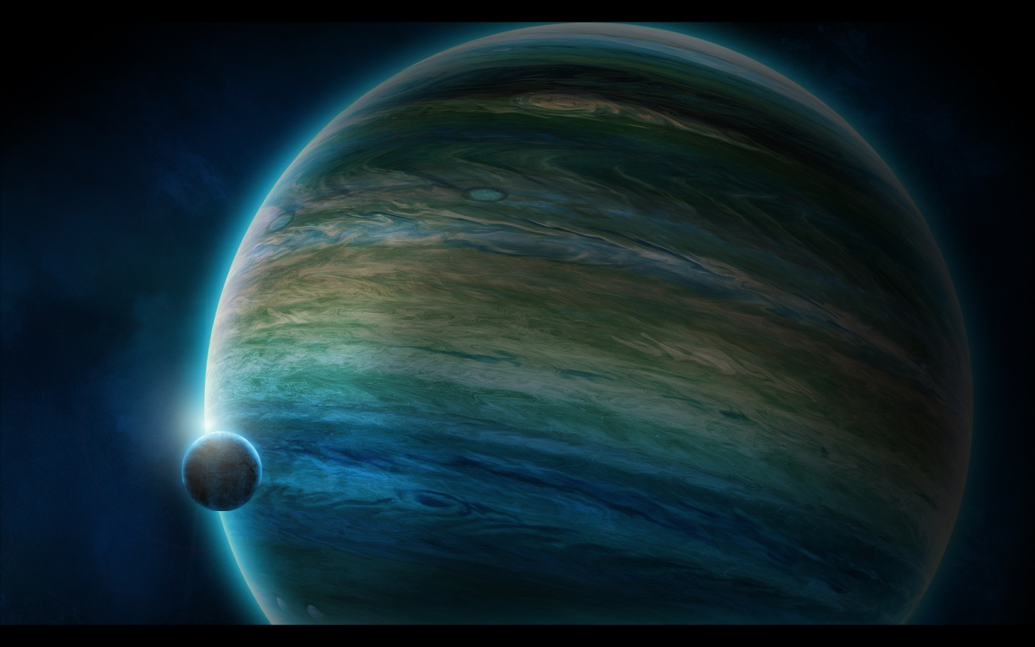
The gas giant Fulgoris and its single orbiting moon Tonitrus.

History
On the boundaries of the Segmentums Obscurus and Ultimas, in a position low on the galactic plane, there is an unremarkable little system with a single astral body, orbiting a weak star. The planet in question was called Fulgoris, a super gas giant, many times the size of Jupiter in the Sol system. It had a single moon which was gripped in a close orbit and circled the lower hemisphere of the planet. The moon was named Tonitrus by the Explorator survey team that ventured into the system some three thousand years ago and it, rather than the giant Fulgoris, proved to have more potential use to the Imperium. Fulgoris itself had vast deposits of minable gases and precipitates, but due to the extremely difficult conditions such as thousand mile an hour winds, a corrosive atmosphere and an overly strong magnetic field, harvesting these resources would have been too costly to be worthwhile, especially given that the same resources were in abundance elsewhere in the galaxy and with much more suitable mining conditions. Tonitrus however, was a different matter entirely.
Were it not for the fact that Tonitrus was caught in the gravitational pull of such a monster as Fulgoris, then it would have been classed as a planet it in its own right, being approximately a third larger than Terra. The moon does have a breathable atmosphere, although it is thin by human standards and re-breathers are recommended for any extended stay on the surface. Indigenous life is sparse and uniquely it is all flora or fungus and no fauna exist on the moon at all, not even the most basic of invertebrates. Initially this should have meant for far more limited plant life then even the little there is on the moon, as throughout the galaxy higher forms of flora have always evolved to rely on some type of animal life to pollenate their species. Another initial mystery was what was providing the atmosphere that encircled the moon? With very limited plant life to provide oxygen, no sizeable bodies of liquid to sustain gaseous emitting organisms and no seismic activity to release gases trapped within the moons core, there should have been no atmosphere at all. The answer to the mystery lay in the greatest boon Tonitrus could offer the Imperium.
Being so close to Fulgoris means that Tonitrus cuts across the gas giant’s intensely strong magnetic field lines during the course of its orbit, generating incredible amounts of electricity. Readings during the initial Explorator survey registered over 4 trillion watts transferring from Fulgoris, across the short stretch of space and wreathing Tonitrus in energy. A great deal of the incredible energy surge is deflected away from Tonitrus by its own magnetic field and the result causes the planet to be wreathed in a constant, hazy blue corona. Of course, not all the energy is deflected. Many, many billions of watts are transferred to the moon’s surface and take the form of some of the most powerful lightning storms ever recorded in the galaxy and it is these storms that oddly enough provided Tonitrus with an atmosphere and life.

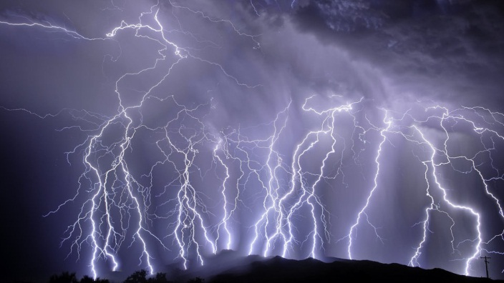
A pict of one of Tonitrus’ minor lightning storms.

Due to the unending transfer of electricity between the planet and moon, Tonitrus’s atmosphere is constantly being oxidised, thus releasing oxygen into the atmosphere. Of course it takes more than just oxygen to make an atmosphere inhabitable to most forms of life and these additional trace elements were brought up into the atmosphere by billions of years of powerful lightning strikes that blasted them free from the moon’s surface. Rocks containing trace minerals were vaporised and became one with the atmosphere and any pockets of trapped gases close to the surface were eventually released by the impact of the lightning bolts.
All forms of plant/fungus life on Tonitrus have evolved to make use of the highly charged environment to sustain them. From the Bio-electric fungus, Ionic Moss, Static Grass and Tesla Trees, Tonitrus was brought to life by the lightning like a creature from some ancient Terran fable.
It is also the lightning, or to be more precise the energy transferred from Fulgoris, that made the Imperium decide to establish a permanent presence on Tonitrus. The eternal electric charge that saturates Tonitrus represents an unending source of energy of such quantity that the Imperium could not pass up the opportunity to make use of it. Within a century of the initial Explorator survey, a vast number of energy harvesting facilities and conduits were built and operational, capturing, refining and exporting the energy drawn from the moons atmosphere.
There were numerous small settlements dotted around the moon to house the workers for the facilities and refineries, but there was only a single hive city, Tempest Hive, deep in the heart of the largest concentration of factories and refineries.
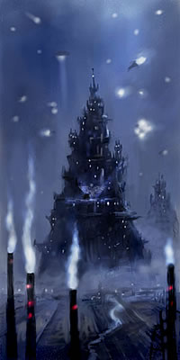
Tempest Hive.

Despite the vast resource there to be tapped, Tonitrus was not an easy place to work or live on. The obvious difficulty was the frequency and sheer power of the lightning strikes. For all the energy that the Imperium siphoned off from the atmosphere, there was still more than enough generated in the moons orbit around Fulgoris to cause lightning storms of such ferocity that an unprotected hive city would be reduced to rubble in weeks. Because of this danger, fully 15% of all the energy harvested had to be immediately put to use powering some of the strongest force fields the Adeptus Mechanicus could provide, protecting Tempest Hive and the larger harvesting and refinery clusters. Those facilities and settlements further out from Tempest Hive do not benefit from the technological wizardry of the Mechanium, as to protect every location on the moon in such a way would be too costly to make the harvesting endeavour worthwhile. Instead, as much of the installations as was possible were constructed underground and those building that had to be built upon the surface were made from as much non-conductive, energy ablative material as was practical. Even so, it is not uncommon for isolated refineries or townships to be destroyed during a succession of particularly large storms.
Another difficulty to deal with was the heavily ionized atmosphere of the moon, which made non-psychic communication to locations outside the force field domes extremely difficult. At Tempest Hive a corridor of static clear space was maintained by a magnetic field that could be projected from the hive spire and reached into orbit. This was to allow for short ranged off world communication, primarily with communication relays and the carrier and patrol ships. The only downside however, was that the protective force field that sheltered the hive city had to be weakened to allow the magnetic field to pass through. When a strong storm approached the force field had to be put back up to full strength once more, cutting communication off from the surface. During a particularly long storm, Tonitrus could be comms silent for days at a time.
At such an effort it is clear that amount of energy harvested from Tonitrus was vast to make the entire enterprise economically viable. While there was some industry on the moon which provided power cells for energy based equipment and weapons, the majority of the energy captured on Tonitrus was exported to the Segmentum Obscurus, Cadia in particular. Vast carrier ships, little more than giant power cells themselves, transported the harvested energy which was used to power the weapons and defences that Cadia and other worlds relied on to keep the forces of Chaos in check around the Eye of Terror. While Cadia and the other planets within the Segmentum did not rely solely the on the energy supplied from Tonitrus (for that would be foolish), the moon fulfilled a sizable proportion of what was needed within that sector of the Imperium. Should production falter, then the temporary shortage of energy in the Segmentum would provide a weakness that the enemies if Man might well take advantage of.
Tonitrus therefore always had a strong and well supplied military force to protect it from any threat. Self-reliance and resourceful thinking were bred into each soldier, as all tours of duty involved rotations at the remote military outposts which guarded the isolated harvesting communities. Given the conditions of Tonitrus, these outposts could be cut off from all supplies, relief forces and communication for extended periods of time. Therefore the environment instilled in the troopers and officers a particular sense of independence and being able to survive and operate on their own. In fact it was this sense of independence which sowed the first seeds which would grow and develop into the conflict that became known as the Storm War.


The Coming of the Storm
For thousands of years Tonitrus provided constant and unending energy and for a time it was a rare jewel in the crown of the Imperium, boasting a productive, peaceful population and free from the constant conflict that engulfed the rest of the Empire of Man. Its location, particularly that of being below the galactic plane, and the sparseness of the system meant that it held little interest to the many foes of Man that might have wanted to claim it as their own. It would have required a gargantuan effort, by any force, to invade that deep into Imperium territory and to assault such an isolated system that due to its sparseness held no means of supporting an invading force. This, coupled with the fact that no other race or faction (other than the Imperium) had the sheer amount of resources available to harvest the energy of Tonitrus, made any form of military action not worth the effort. Even a successful assault on the world would leave the conquering force overstretched in an isolated system, with no way of holding onto their prize when the vengeful Imperium would arrive to reclaim what was once theirs.
And so it was that over time the Imperium began to grow arrogant in its secure rule of Tonitrus. At first a dozen cruisers and strike craft maintained a constant patrol around the system. A few hundred years later and the lack of any form of threat had reduced this fleet to a mere picket line of a few light frigates, as the needs of the Imperium called the rest of the fleet to more pressing duties. A thousand years later and all that remained was a single frigate and a squadron of destroyers that were weighed on almost permanent anchor in high orbit above Tonitrus. There was no need to even escort the energy carrier ships from the warp translation point further in system to the moon. There was simply no threat.
As with all unseen components in a machine that continue to work perfectly, they tend to be forgotten and ignored. So it was that Tonitrus, in its quiet and isolated part of the universe, became just another cog in the greater machine of Man and was neglected by the rest of the Imperium at large. Obviously the carrier ships continued the continuous export of energy and supply ships provided the moon with the necessities needed for the continuation of human life on the moon. But all these things were controlled by numbers in the vast entity that was the Administorum. No one actively took notice of the shipping logs or supply manifests. Each day a lowly worker pushed the same routine of buttons again and again, without even understanding what he was doing. This was all the effort it took to keep the status quo on Tonitrus and a million other worlds within the Imperium.
The isolated existence of Tonitrus continued century after century until relatively recently. Despite being as neglected as they were, the people of Tonitrus were used to a certain standard of support from the Imperium (after all they could not easily produce food in such a hostile environment) and so it was with some indignation that they found that fewer and fewer supplies and resources were being shipped to Tonitrus. When Tobias Crom, the current Planetary Governor of Tonitrus, received a response to his queries as to why supplies were waning, he was simply told that resources were needed elsewhere and had to be prioritised. For a several decades this was the only reason the Governor was given, while supplies shrank to barely sustainable levels. The heads of the civilian and military authorities continually pressured the Governor for more information and action to rectify the shortage of supplies.
In truth the Imperium had become complacent about Tonitrus, as it had with many of its worlds. As far as the Imperium was concerned, Tonitrus was just another world with a tithe to fill and would continue to do so in spite of whatever complaints the Governor might have. But as with many people who live on the edge of existence, the people of Tonitrus were independent and strong willed and they could not allow themselves to simply wither and die, no doubt to simply be replaced by the Imperium afterwards.
After mass petitions by the population and news from around the moon that the people were suffering, Governor Crom felt he was left with no other choice. Whereas other Governors may well have suppressed any dissent with force, Tobias Crom was a compassionate and sympathetic ruler (an extremely rare thing in the Empire of Man). So instead he decreed that just as the Imperium was starving them, they would starve the Imperium in turn and ordered energy levels exported from Tonitrus to be halved. When the Administorum contacted the Governor to query why there was such a reduction, they were told that energy exports would continue to steadily decrease until supply levels were raised back to their former levels. The Governor also advised that the entire moon’s population supported him in this action and that simply removing him from power would not alleviate the situation. Not known for their understanding or leniency, the Imperium immediately declared the Governor and population as traitors and ordered Imperial forces to make best speed for Tonitrus to forcibly remove Governor Crom and either subjugate or exterminate the populace for treason.
The Governor was pained by this response, although in his heart he knew this would be the most likely outcome of his actions. But what other options did he have? His petitions for more supplies were falling on deaf and uncaring ears. He did not even have the option of illegal trading with freebooters or xenos, as none plied their business anywhere near the system due to its isolation. All the Governor could see for the people under his care was a long, drawn out death from starvation as supplies continued to decrease to unsustainable levels. By contrast the brutal, but quick death brought by the vengeful forces of the Imperium might be seen as a more merciful end. But the Governor would not simply lay back and let his people die.
There was hope that if the military garrisons stationed on Tonitrus could hold back the invading force for long enough, the energy shortage would begin to cause significant problems elsewhere in the Segmentum and the Imperium might then be prepared to negotiate. Governor Crom hoped that given the option of either letting the defences around the Eye of Terror weaken for a prolonged period of time, or agreeing to their demands, the Imperium would opt for the lesser of the two evils. Crom knew that this was an exceedingly unlikely outcome and that even if it did succeed he would likely be ‘removed’ from office not long after, but the populace might be spared.
While they would not be able to hold out forever Tonitrus was more ideal at weathering an invasion than first appeared. While there was little in the way of orbital defences and no great fortresses as there was on Cadia, the force fields protecting the major population and industrial zones were strong enough to withstand almost any form of orbital bombardment. Once on the ground the attacking forces would also have to contend with the natural dangers and hindrances of the moon, such as the lightning storms and communication disruption. The military forces stationed on Tonitrus had also always remained well supplied with weapons, ammunition and vehicles, yet had previously never much cause to use them. Therefore they were exceptionally well prepared to fight off any form of assault short of an all out assault by the Titan Legions. Taking all this into consideration, an invader would be hard pressed to conquer the moon in a short space of time.
The dye having now been cast, what food and supplies the people of Tonitrus had been able to stockpile was stored safely away and the planetary garrison prepared itself for the coming battle. None of them could have imagined the war which would follow.



Once the behemoth like institution of the Imperium had fully awoken and become aware of the events on Tonitrus, they realised only too well what prolonged energy shortages from would mean. Defences in key areas would be compromised, as orbital and macro weapons systems would be reduced to ammunition rationing and defensive shielding would weaken. Should the forces of Chaos or xenos learn of this then it is more than likely that one of mankind’s enemies would launch a large scale assault, maximising their opportunity and swamping the weakened defences. The moment the Governor and people of Tonitrus were declared traitors plans were put in place to begin energy supplies from alternate sources to the areas affected. But this would take time and not all alternate supplies of energy could make up the deficit, as they already had other worlds to supply.
The Imperium was mustering a large scale planetary subjugation force which would eventually depose the rogue Governor and replace the entire population, but this would take months to mobilise. Immediate military intervention was required to re-establish control over the moon and return energy exports to their full levels. Therefore, the closest Imperial forces were ordered to cease all current activities and make best speed for Tonitrus, with the objective of seizing control of the moon and energy production. Two forces were within a week’s warp travel of Tonitrus and they answered the call to battle.
The first was a Space Wolf strike cruiser, The Wolf’s Bite, belonging to the Great Company of Gunnar Redmoon, and on their way back to Fenris after a joint mission with the Blood Angels, driving out the Dark Eldar pirates who had been harrying Imperial worlds in the North of the Segmentum Ultimus. Battle had favoured them and they carried few losses, which meant that almost the full might of a Space Wolf strike force would be brought to bear on the citizens of Tonitrus.
The second to respond to the Imperium’s call was a smaller force of Dark Angels, operating on board the frigate The Vengeful Sword. Oddly, it was unknown why this Dark Angel vessel was in that particular region of the Segmentum and they had been originally headed. The Dark Angels on board The Vengeful Sword constituted little more than a raiding party, and the adepts of the Administorum could find no mission log that had been filed to explain what such a small force was doing so far from all other know current Dark Angel theatres of operation. But the need for a fast and efficient victory on Tonitrus was crucial, therefore the higher powers in the Imperium were not concerned as to why the Dark Angels were in the region, only that their assistance in the matter would greatly speed up a resolution.
And so it was that the might of two of the most famous and revered chapters of the Adeptus Astartes were set on course to wage war. But there was one more player to this game. One who had remained in the shadows, but now saw fit to reveal their hand.



During the years of starved supplies, the citizens of Tonitrus had relied on their natural resourcefulness and resilience to hardship to sustain them. However, desperate times can drive people towards desperate acts and so it was that a small minority turned to darker powers for aid.
Physical isolation means nothing to the ruinous powers that dwell in the Warp. Therefore when the few voices prayed in the night for salvation of any kind, the Gods of Chaos heard them. They cast their myriad baleful eyes to this seemingly insignificant moon and listened to the people beg and plead. At first they merely took pleasure from the suffering the Imperium was inflicting on its own people. But over time they decided to take more of an interest in this remote ball of lightning wracked rock and an opportunity of terrible proportions revealed itself.
The power that coruscated between Fulgoris and Tonitrus was vast as has already been described and, just as the Imperium had done, the Chaos Gods realised they could harness this energy for their own needs. A Warp gate.
Warp gates take a tremendous amount of energy to form and even then they do not usually last for long. Only cataclysmic astral events can release enough energy to create permanent portals to the Warp, leaving great scars in the fabric of space and reality, such as the Eye of Terror or the Malestrom. However, the Chaos Gods realised that if their pawns in the physical realm could take control of Tonitrus and channel all the energy harvested to a Warp gate, then they could open a rift to the realm of Chaos which would remain open permanently, continuously fed the energy it required by the unending transfer between Fulgoris and Tonitrus. Remote as the location was, it would still allow Chaos another doorway into reality and afford them a staging ground from which to strike out at the underbelly of the Imperium.
Such a plan was not simply to be entrusted to the deranged cults that had arisen in the shadows on Tonitrus. As adept at concealing their worship from others as they were, it was doubtful that mere corrupted citizens could have staged such an effective coup, or at the least provided an opportunity for the forces of Chaos to attack. Therefore it fell to the Alpha Legion, masters of espionage, to infiltrate the moon and make the path clear for a large scale Chaos assault. Such ground work would be vital, as until the Warp gate was open the Chaos invasion force would be isolated in the remote system and too far removed from any support.
The invasion was not a task suited to the more dedicated and devout Chaos armies, those who were either mindless bezerkers or debased worshippers. This war needed to be waged by a skilled force that could operate under strict discipline and orchestrate the campaign with a keen tactical mind. So it was that the Black Legion, who still operated with a great deal of the efficiency and discipline of the Space Marine Legion they once were, was tasked with the mission to attack Tonitrus and open a Warp gate. Those Alpha Legion forces that had been hiding in the shadows would also assist them in prosecuting the war when they arrived, providing infiltration and subterfuge to compliment the front line combat of the Black Legionnaires.
Unfortunately for the forces of the ruinous powers, Governor Crom’s desperate act of defiance may well have proven to be their undoing. They knew they would need to defeat the planetary garrison, but they had not expected there to be any additional forces to resist them. Knowing the Imperium would immediately dispatch whatever armies it could to re-gain control of the moon meant the Black Legion had to invade as soon as possible. They needed to conquer Tonitrus and establish the Warp gate before the Imperium’s own invading forces arrived, otherwise what was intended as a blitzkrieg war would turn into a drawn out campaign they could ill afford.
So it was that the three factions made ready for war. One fought simply for their right to survive and be recognised, another sought to oppress a traitorous act of rebellion and the last sought to open up hell on Tonitrus.
Who would win? Only time would tell…



