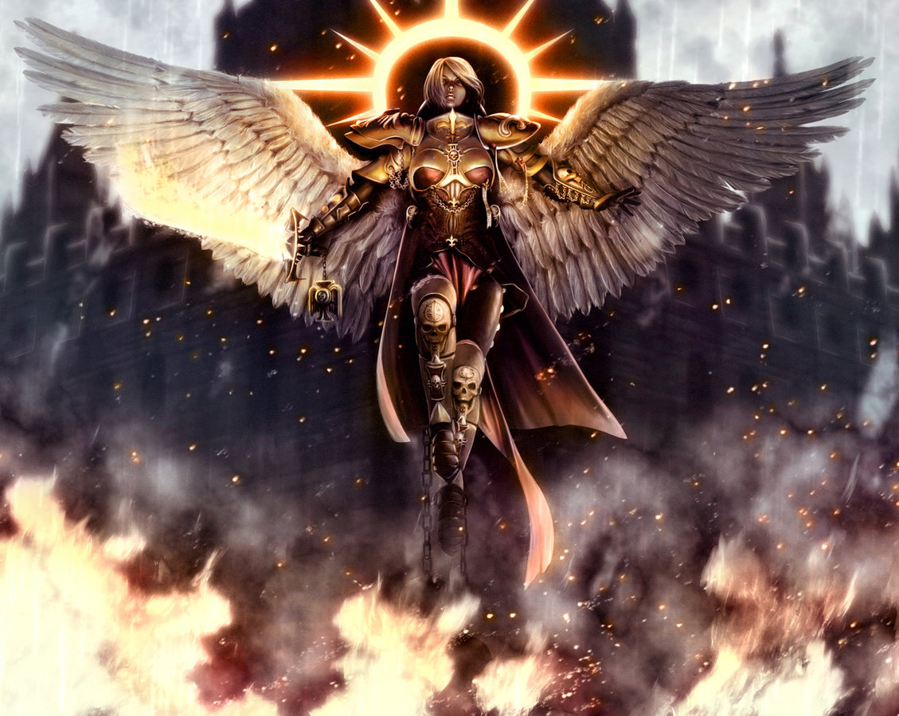
In 2016 There Is Only War!
What: 1850pt Warhammer 40k Tournament
When: Saturday January 2
Where: FourHorsemen Comics, Morgantown WV

