Devram Korda: The Tyrant of Sarora, Chosen of Abaddon
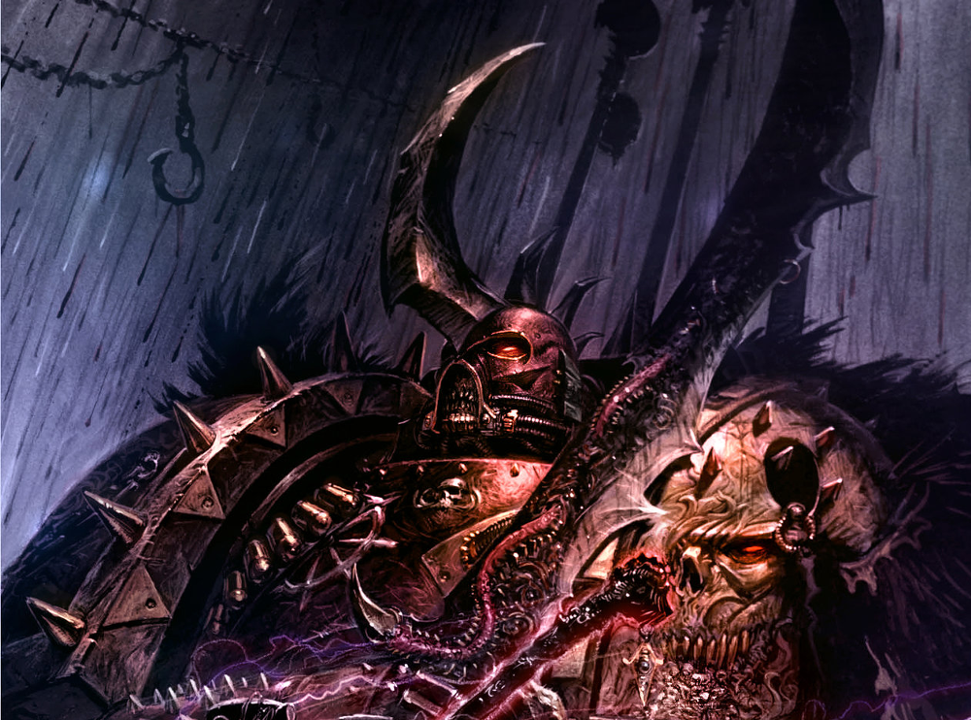
Devram Korda did not share the same opinion as his brothers concerning the allies they employed during the Horus Heresy and believed that they alone could win the Imperium from the Emperor. He still held true to some of the ideals the Astartes had had before Horus rebelled and was gravely concerned at the cancer that was introduced and worming its way into his Legion. However his loyalty to his brothers, Luc Sedirae his company commander above all, and his Primarch pulled him along with the tide that was over taking the now Sons of Horus.
‘It stank of Witchcraft’ said the Astartes
Erebus smiled thinly. ‘Don’t concern yourself with such issues, brother-sergeant. This was but one of many other arrows in my quiver’.
‘I grow weary of your games and your riddles,’ said Korda. He swept his hand around. ‘What purpose does any of this serve?’
On Dagonet an assassination attempt sent by the forces of the Emperor on the Warmasters life was made but thwarted. In Horus’ place Sedirae was sent and killed. Seeing the head of his commander fall to the floor and his body crumble deeply wounded Korda to his core and broke any last remnant of his former self, taking revenge on the population of the doomed planet. Korda became a man of sudden rages and committed heinous acts against any loyalist forces that the Sons of Horus faced, even unarmed citizens would meet a disturbing end at the hands of Korda. Taking note of the pleasure that Korda took from each act of revenge against his victims the Dark Prince Slaanesh whispered to Korda and offered him many things to bring him to his breast. However, unlike many of his brothers, Korda never lost his distrust of the warp spawned monsters and stayed true to his genehanced mortality.
On the soil of Terra at the gates of the Imperial Palace Devram Korda fought harder than he had ever thought before, vengeance for his commander was within his grasp and the false Emperor would fall. But as he reached the final gate baring his path and his latest foe fell from his blade a great psychic cry pierced the mind of each Son of Horus, the Warmaster had been slain.
Revenge denied for now he fled Terra and joined his brothers in retreat vowing that one day he would return.
He joined the other Sons of Horus in their journey to the Eye and settled for a time on the Crypt World of Maeleum but being in the realm of the warp did not sit well within him and left along with a handful of his closest warriors. His time within the Eye had not been fruitless and he recognized the great power that it brings, especially the advantage of the increase to life span, but he would not remain nor be tainted by its touch but required the same longevity to continue the long war.
He had learnt of the experimentations carried out by the notorious Emperors Children Apothecary Fabius Bile and with his allies he sought him out to learn what secrets he could from the twisted astartes. He found Fabius on a world of tortured flesh and madness with his abode amongst the screaming tortured souls of his subjects. Korda approached Fabius and requested his assistance, for no Son of Horus would beg, but everything from the Primogenator comes with a price. In exchange for the secrets of immortality and what he knew of the Machinations of the Dark Prince, for Korda would inevitably feel his caress again, Bile wanted a simple thing, the ability to start afresh, the Warmaster.
Upon completing his learning Korda revealed to Fabius the location Maeleum, its defences and the number of Sons of Horus still located there. Korda left Fabius to his schemes and set off with his men to leave the Eye and forge his own destiny outside it.
Fearing reprisal from the vigilant forces of the Imperium Korda infiltrated the most heavily populated planet he could find to put his vile plan for immortality into action, the hive world of Sarora. It is not known how Korda was able to achieve such an atrocity but using the knowledge he gained from Fabius he distilled the population of Sarora’s largest hive into a single vial of elixir, rendering him almost immortal. The world fully under his heel Devram Korda became the Tyrant of Sarora.
Learning of what has transpired the Emperors Children, at the behest of Fabius, who’s lair and experiments had recently been destroyed, most importantly to him his attempts at cloning the Warmaster, by the forces of the Sons of Horus now led by Abaddon, launch an assault on Sarora desiring what Korda has done for themselves. Leaving the Planet to its demise Korda is able to escape and return once more to the Eye of Terror and due to his Elixir he no longer feels the touch of the warp as he once did.
Drifting from world to world Korda and his men survived in the Eye until they once more met with their former brothers of the Sons of Horus, now renamed the Black Legion. Abaddon himself requested audience from Korda aboard the Vengeful Spirit, something that Korda could not deny. Korda was intrigued to learn how Abaddon had reunited the Legion and how he had made it powerful once more. Korda had fought alongside Abaddon many times and had always been impressed by his physicality and presence but this person was someone else. He had become a behemoth of an Astartes and power exuded from every pore of his flesh and joint of his armour. They spoke for many hours, Abaddon telling stories of his dark travels in the Eye and of how he had taken the mantle of Warmaster upon himself. As their time together was drawing to a close Abaddon also revealed that he was aware of the pact Korda had made with Fabius and for the first time in his life Korda knew something akin to fear. He might be almost invulnerable and have no fear of death, but he was sure that Abaddon would deliver such pain upon him that he would wish that he were. 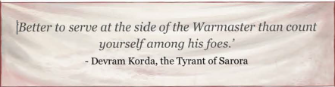
Abaddon explained that he did not blame Korda for his actions, for it was the tie to Horus that was holding the Legion back, and that Abaddon had requirements for the likes of Korda to serve him. Knowing his peril and recollection of old oaths that were once sworn in times gone by, Korda bowed his knee to a new Warmaster.
Abaddon did great honour to the once Tyrant of Sarora and named him as one of his chosen. His knowledge of the workings of Slaanesh has also given him great power within the Black Legion amongst the depraved and pleasure seeking followers of the Dark Prince, although his loathing for these creatures is barely contained.
At the beginning of the 13th Black Crusade Abaddon has tasked Korda with retrieving the Hand of Darkness from the very depths of the Eye, His seeming immunity to the warps touch making him the ideal choice
Vial of Sarora: A vial containing the distilled essence of the largest hive city of Sarora. It also leaves its bearer untouched by the power of the warp. The Vial of Sarora grants Eternal Warrior and a 4+ deny the witch roll. In addition when a challenge is won, do not roll on the Gift of Mutation table. Korda is not under the Eye of any of the Chaos Gods.
Venger: A great two handed blade scored and stained by the blood of countless fallen.
Str + 1 Ap2 Shred
Teachings of a monster: Devram Korda learned much from his time with Fabius Bile to represent this he has the feel no pain (4+) Special rule.
Difficult Alliances: After Fabius revealed Kordas intentions to his Emperor Children allies, and their assault on Sarora, Korda has a great distrust of them. If your force contains any models with the Mark of Slaanesh or Fabius they are treated by him as Allies of Convenience.
In addition to these rules Devram Korda has those listed below. If you do not wish to include Devram Korda as the leader of your Black Legion force you may choose a Chosen of Abaddon Chaos Lord with the following profile and may select items from the Chaos Wargear list. The Chosen of Abaddon benefits from the below rules.
Chosen of Abaddon: (Stats go here)
We Are Returned!: The Chosen of Abaddon and his unit have the Preferred Enemy: Space Marines special rule.
Legion Mark:
Mark of the Despoiler: The Black Legion, the warriors of Abaddon, Warmaster of Chaos, have waged more wars on the Imperium than any other Chaos Legion, always leading from the front when a Black Crusade is called. All Black Legion Units have Veterans of the Long War for free and may take an Elites choice as troops for each troops choice selected.

